The content provided is current and timely as of September 2023.
Information is presented in summary form; policies, procedures, fees and course titles are subject to change.

Nondiscrimination/Equal Opportunity Statement
In compliance with Titles VI and VII of the Civil Rights Act of 1964, Title IX of the Education Amendments of 1972, Section 504 of the Rehabilitation Act of 1973, the Age Discrimination in Employment Act of 1967, the Americans with Disabilities Act, the Genetic Information Nondiscrimination Act of 2008, Colorado law and Board of Education Policy AC (Nondiscrimination/Equal Opportunity), Weld County School District Re-8 does not discriminate on the basis of disability, race, creed, color, sex, sexual orientation, gender identity/expression, national origin, religion, ancestry, need for special education services, age, marital status, genetic information, or physical characteristics in admissions, access to, treatment, or employment in educational programs or activities which it operates. Complaint procedures have been established for students, parents, employees and members of the public. The following person has been identified as the compliance officer for the district: Superintendent, Weld County School District Re-8: 200 South Fulton, Fort Lupton, CO 80621, 303.857.3200, superintendent@weld8.org

9/02/22

Table of Contents

Administration and Counseling ................................................................................................... 4
Registration Policies .................................................................................................................... 4
Graduation Requirements............................................................................................................ 5
English/Language Arts Flowchart ................................................................................................ 8
Mathematics Flowchart ................................................................................................................ 9
Science Flowchart...................................................................................................................... 10
Social Studies Flowchart............................................................................................................. 11
College Information.................................................................................................................... 12
Sample Admission Criteria College Entrance............................................................................. 13
Student Four-Year Plan Worksheet............................................................................................ 14

Academics

English........................................................................................................................................ 16
Mathematics............................................................................................................................... 20
Science....................................................................................................................................... 24
Social Studies............................................................................................................................. 28
World Languages........................................................................................................................ 31

Electives

Art............................................................................................................................................... 35
Engineering……………………………………………………………………………………………... 37
CTE Family and Consumer Sciences (FCS) Pathway................................................................ 38
CTE Business Pathway.............................................................................................................. 39
CTE Multimedia Pathway............................................................................................................ 41
Music: Instrumental & Voice with Drama.................................................................................... 42
Physical Education..................................................................................................................... 43
AVID & Gifted and Talented Program......................................................................................... 45
Tutoring, Office and Teacher Aide.............................................................................................. 46
Exceptional Student Services..................................................................................................... 47
Aims Community College........................................................................................................... 49

Special Programs Information

Guidance and Counseling.......................................................................................................... 49
Naviance Family Connection...................................................................................................... 51
Upward Bound, Talent Search and CU Pre-Collegiate............................................................... 51
Counseling Department Career & Educational Planning Calendar............................................ 53

High School Administrators and Counselors

Principal (2022-2023)
Mr. Doug Gordon
Assistant Principals
Mr. Nate Jacobson (A-L)
Mr. Rick Jacoby (M-Z)
Counselors
Erik Padilla (A-L)
Maribel Marquez (M-Z)

Registration Policies
Enrollment Requirements
Students are required to be enrolled in and complete a minimum of five classes each
semester. Students may be required to take more than five classes depending on their
successful completion of course credit that lead to fulfilling graduation requirements.

Schedule Changes
Schedule changes are granted only with the approval of a counselor and school administrator. Students should choose their classes wisely during registration because changes are often not possible at the beginning of a semester. Students must follow their original sched- ules until schedule changes are granted. Changes are only made for incorrect level, prior se- mester failure, or class conflict. Changes will not be made for teacher/period preference.

Adding/Dropping Classes
All class modifications must occur no later than the end of the first week of the semester.
Classes dropped after two weeks will result in a grade of WF (Withdraw Fail) or WP (Withdraw
Pass) as indicated by the teacher. A Withdraw Fail will affect the cumulative GPA. See your counselor for the necessary form.

Grades and Credit
All classes at FLHS are worth .5 credit per semester unless otherwise noted. Progress report
grades are issued every six (6) weeks. Only semester grades are recorded on transcripts.

Make Up Course Opportunities
Students who fail classes must schedule an appointment with their counselor to explore credit
recovery options. Students may not be able to continue on the required sequence of core classes unless they show an effort to make up failed classes in summer school, online or
through correspondence courses. Courses must be NCAA approved for college bound athletes.

Course Fees
Some courses have additional required fees to cover expenses. Fees are listed in the course
descriptions. The fees will be collected at the beginning of the school year. An * designates
additional costs that may be incurred, but are not collected at the beginning of the school year
(ie. AP classes, Science, Music, etc).

Weighted Grades
Courses are graded on a 4.0 scale except as designated below.

Advanced Placement Courses
Advanced Placement courses are weighted on a 5.0 scale. Students enrolled in these classes will need teacher recommendations. There is an exam fee for each AP course taken. College credit may be available for qualifying exam scores.

Pre Collegiate Courses
Pre Collegiate courses will be offered to all students. These courses will be weighted on a 4.5 scale. Students enrolled in these classes will need teacher recommendations.

Concurrent and Career Academy Courses
Concurrent and Career Academy courses apply both to college credit and high school credit. The grade will be weighted on a 4.5 scale. Students must be enrolled at FLHS for an entire academic school year in order to be eligible to enroll in these classes.

Valedictorian Selection
Candidates will be selected among FLHS students who have the highest weighted GPA. In the case of a tie, Advanced Placement courses and results on State Assessments (ACT, SAT, and PARCC) will be considered. Students must be enrolled at FLHS for an entire academic school year for consideration. Final selections are at the discretion of the Principal.

MTSS (Multi-tiered system of support)
MTSS is an approach that promotes a well-integrated system connecting general, compensatory, gifted, and special education in providing high quality, standards-based instruction, and intervention that is matched to students' academic, social-emotional, and behavioral needs. Fort Lupton High School uses the following interventions to support MTSS: AVID, Gifted and Talented, and Exceptional Student Services.

FLHS Graduation Requirements
English 4.0 Credits  English 9 1.0 Credit  English 10 1.0 Credit  English 11 1.0 Credit  English 12 1.0 Credit  Mathematics 3.0 Credits  One year of Algebra 1, one year of Geometry, and one year of Geometry equivalent or higher  Science 3.0 | Social Studies 3.0 Credits  (must include Civics and Economics)  Electives/Fine/Practical Arts 10.0 Credits  (Art, World Language, Business, CTE, Music, Physical Education, etc.)  Total 23 Credits

Weld Re-8 Schools are committed to preparing well rounded students of character, scholastic achievement in order to prepare students for living full and complete lives in the 21st century. One part of that preparation is a pre-collegiate and a postsecondary career pathway combined with rigorous curriculum that prepares students for success in the next step beyond high school. Success in college and/or in the choice of a postsecondary career education pathway integrated
with rigorous curriculum prepares students to pursue admission to universities, community colleges, or apprenticeships.

Weld Re-8 Academic Standards
To receive a high school diploma from Weld Re-8, students must meet or exceed the district's academic standards by demonstrating one or more measure(s) of college and career readiness as listed below or complete the requirements and goals as listed on a student's Individualized Education Program (IEP), which may include modified academic standards.

Demonstration of College and Career Readiness

 | English | Math
Accuplacer assessment | 62 on Reading Comprehension or 70 on sentence skills | 61 on Elementary Algebra
ACT assessment | 18 on English | 19 on Math
ACT Compass assessment | 79 on English | 63 on Math
ACT WorkKeys | 3 (Bronze level) Locating Information, and Reading for  Information. | 3 (Bronze level) Applied Mathematics, 3 (Bronze level) on Mathematics
Advanced Placement (AP) | 2 on AP exams | 2 on AP exams
Armed Service Vocational  Aptitude Battery (ASVAB) | 31 | 31
SAT Assessment | 470 on English | 500 on Math
State Standards Performance Assessment | Proficient in English/Reading | Proficient in Math
Concurrent enrollment course | C in concurrent enrollment eligible English course | C in concurrent enrollment eligible Math course
Industry Certificate | Demonstrating career readiness in English | Demonstrating career readiness in Math
Weld Re-8 District Capstone  *Capstone project required of all  students beginning with the Class of 2020 | Approval by a district-designated  reviewer verifying that the student has demonstrated academic and  intellectual learning in the subject of English | Approval by a district-designated  reviewer verifying that the student has demonstrated academic and intellectual  learning in the subject of Math

Being prepared for the 21st century requires the appropriate use and application of technology. All courses integrate technology as a part of the instruction in that content. All course work infuses skills necessary for success in the 21st century. Those skills, in addition to the use of technology, include:
• Information processing and analysis
• Critical thinking and problem solving
• Interpersonal skills and self direction
• Community, state, national and global awareness
• Financial, economic, and business literacy
• Entrepreneurial skills
• Civic literacy
• Skills for continuous learning

The Role of the Comprehensive High School in Graduation
Our comprehensive high school has been designed to serve the needs of students in grades nine through twelve. The comprehensive high school will balance core academic expectations for all students in the achievement of content standards while serving the diverse talents and interests of our students. It is the combined responsibility of staff, students, and parents/guardians to ensure that students meet the core academic expectations and develop those talents and interests over the four years of high school. The comprehensive high school in Weld Re-8 will provide students with the academic workforce. In addition, students will be instructed about, and be expected to be, participating citizens. Students will adhere to the Weld Re-8 High School Positive Student Behavior Expectations up to and including the day of graduation. Graduation shall be the culminating event for students after they have met the requirements for a Weld Re-8 diploma.

Definition of Graduation
The following criteria shall entitle a student to a high school diploma from Weld Re-8 School District.
• Achievement in content standards as demonstrated by mastery of the curriculum which may include, but is not limited to, daily classroom assignments, the Colorado student assessments, the district assessments program, classroom assessments, and the completion of assigned projects approved concurrent enrollment and approved online learning.
• Weld Re-8 has the authority to adapt the college and career demonstrations necessary to earn a standard high school diploma to accommodate for English learners, gifted and talented students, and students with disabilities

A unit of credit is defined as the amount of credit given for the successful completion of a course which meets a minimum of 40 minutes daily, five days per week for one year (36 weeks) on a traditional schedule or a four or more hour college semester hour course (1 credit); the equivalent time is equal to 120 clock hours. One-half credit is given for successful completion of a class that meets at least 40 minutes daily five days per week for one semester (18 weeks) on a traditional schedule or a two or more hour college semester hour course. Principal or designees may submit approval for specialized courses such as academic electives and/ or student aide to carry .25 credit. Nontraditional schedules will be translated to this standard for the purpose of determining course credit.

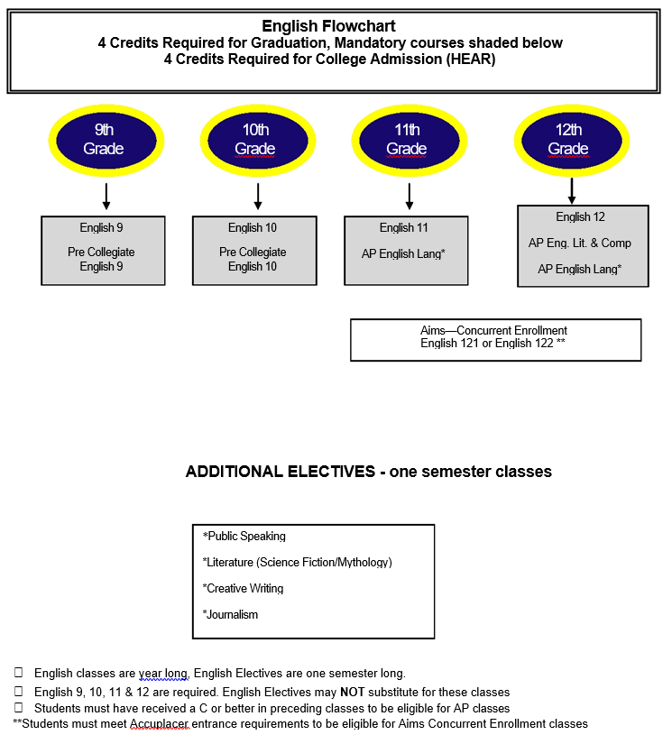
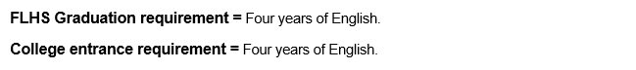

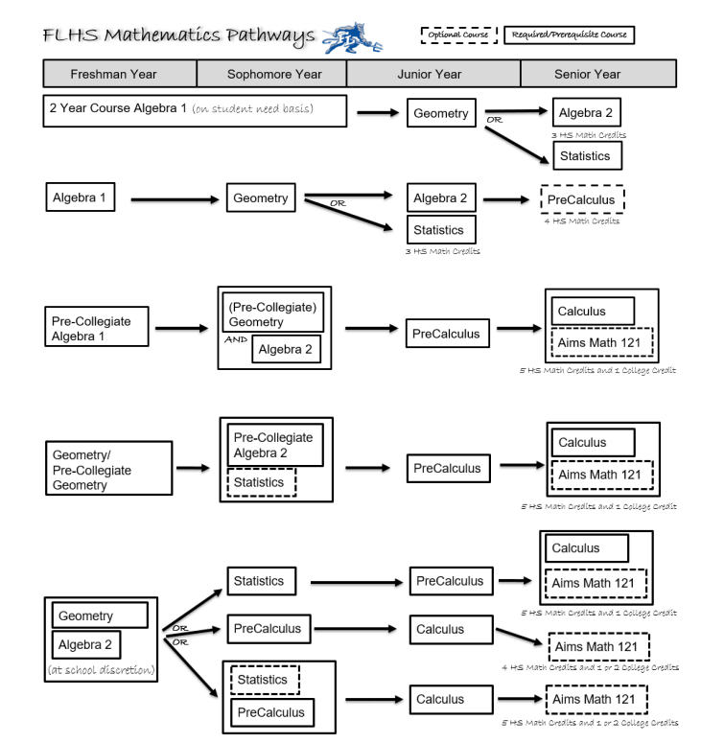

Math classes are year-long courses.

9th Grade students on the accelerated path will be tested at the end of their 8th-grade year for correct placement.

**Students must meet SAT/Accuplacer entrance requirements to be eligible for Aims Concurrent Enrollment classes.

FLHS Graduation requirement = One year Algebra I, one year Geometry, and one year additional course at or above Geometry

College entrance requirement = Four years of Mathematics (must include Algebra I, Geometry, Algebra II or equivalents)

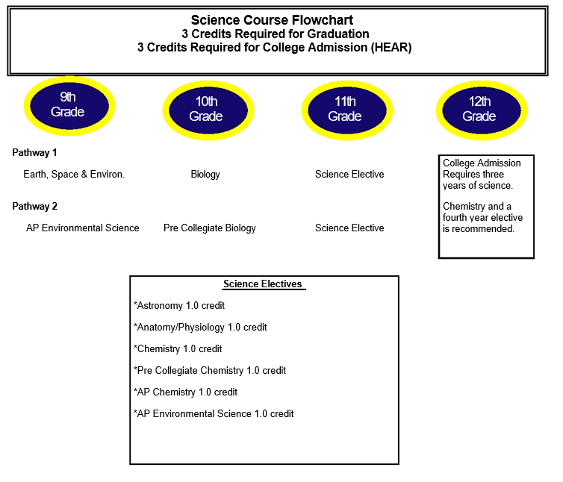
All FLHS Science classes are considered laboratory sciences.

FLHS Graduation requirements = Three years of science courses are required.

College entrance requirements = Three years of Natural/Physical Sciences (two of which must be laboratory sciences).

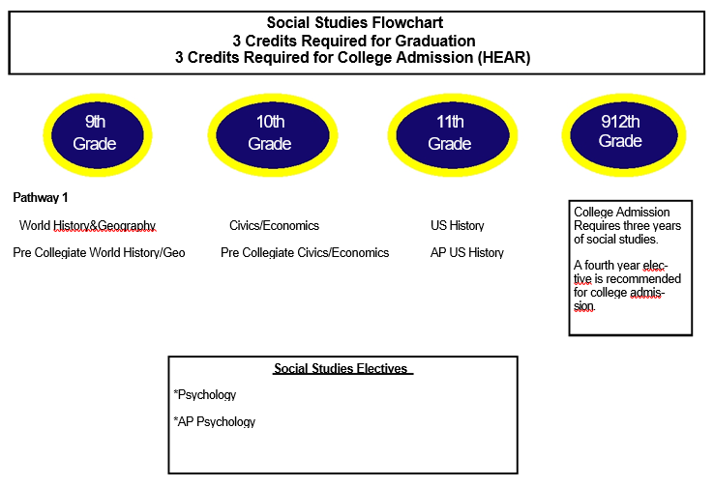
FLHS Graduation requirement = Three years of social studies courses are required. Civics is required for the Class of 2020 and beyond.

College entrance requirement = Three years of social studies but a fourth year elective is recommended for college admission.

College Information
One choice for our students is the university system in Colorado. The entrance requirements for admission to any Colorado four-year university (Higher Education Admission Requirements or HEAR) are printed in the policy. They are not identical to the requirements for graduation from Fort Lupton High School.

Students must meet the following requirements to be considered for admission to a Colorado, four-year university.

Higher Education Admission Requirements (HEAR)
In accordance with a policy passed by the Colorado Commission on Higher Education (CCHE), students who are admitted to any Colorado public four-year college and/or university must complete the following courses which compromise a solid pre-collegiate curriculum:
- Four years of English
- Four years of Mathematics (must include Algebra I, Geometry, Algebra II or equivalents)
- Three years of Natural/Physical Sciences (two of which must be laboratory sciences)
- Three years of Social Studies
- Two years of academic electives
- At least one year of a World Language

Prospective Collegiate Student-Athletes
Many college athletic programs are regulated by the National Collegiate Athletic Association (NCAA), an organization founded in 1906 that established rules on eligibility, recruiting, and financial aid. If you are planning to enroll in college as a freshman wishing to participate in Division I or II athletics, you must be certified by the NCAA Initial-Eligibility Clearinghouse. The Clearinghouse ensures consistent application of NCAA Initial-Eligibility requirements for prospective student-athletes at all member institutions.

Eligibility
- Registration must be completed by going online to: www.ncaaclearinghouse.net.
- A $60 registration fee payable with a credit card will be needed at the time of registration.
- Check the approved core course list (this is the student's responsibility; courses change yearly).
- Division 1 and 2 require a minimum of 16 academic course units as follows:
4 years of English
3 years of Math (Algebra I or above)
2 years of Science (1 year of lab science)
2 years of Social Studies
1 additional year of English, Math, or Science
4 years of additional courses from list, or second language

Not all Fort Lupton High School courses are recognized by NCAA. You may find a list of NCAA approved courses at
www.eligibilitycenter.org. Click on Resources, click US Students, and click List of NCAA courses.

You must have a core course GPA of 2.0 (based on a 4.0 scale) and a combined score on the SAT verbal and math
sections, or a sum score on the ACT based on the qualifier index scale which can be found on the NCAA website or
contacting 1-877-262-1492. (Computer Science is no longer a core course).

College Opportunity Fund
The College Opportunity Trust Fund, created by the Colorado Legislature, provides a stipend to eligible undergraduate
students who are Colorado residents for tuition purposes. The stipend pays a portion of your total in-state tuition when
you attend a Colorado public institution or a participating private institution. Eligible undergraduate students must apply,
be admitted, and enroll at a participating institution. Both new and continuing students are eligible for the stipend. The
stipend will assist with the first 145 credit hours of your undergraduate degree program at a Colorado college. Qualifying
students may use the stipend for eligible undergraduate classes. The stipend is paid on a per credit hour basis to the
institution at which the student is enrolled. The credit-hour amount will be set annually by the General Assembly. The
application to apply for the stipend is currently available at www.collegeincolorado.org; click on "College Opportunity
Fund." All Colorado residents should apply for the College Opportunity Fund in order to offset the entire cost of tuition at
each college.

SAMPLE ADMISSION CRITERIA FOR COLLEGE ENTRANCE
4 Major Factors for College Admission
If your plans after graduation from high school include college, you should keep in mind the four major factors upon
which college admission is based
• Quality of your courses of study while in high school
• Grades earned in these courses and the resulting grade point average and class rank
• Test scores on the ACT and/or SAT tests
• Activities of recommendation when appropriate
Admission requirements to colleges and universities vary greatly. Students should seek information about the colleges
or universities they are interested in attending to determine the exact requirements. Catalogs may be obtained from
the college or your high school postgraduate or counseling center.
GENERAL COLLEGE REQUIREMENTS
The following colleges and universities are listed according to the levels of entrance difficulty developed by Peterson's, a leading provider of education data.
Most Difficult | Very Difficult | Moderately Difficult | Minimally Difficult
Examples: US Air Force Academy, Stanford, Harvard, Duke | Examples: Colorado College, Colorado School of Mines, Pepperdine University, UCLA | Examples: University of Colorado/Boulder, University of Denver, Colorado State | Examples: Metropolitan State, Mesa State, Johnson & Wales
More than 75% of the freshmen were in the top 10% of their high school class and scored over 1310 on the SAT 1 or over 29 on the ACT. About 30% or fewer of applicants were accepted. | More than 50% of the freshmen were in the top 10% of their high school class and scored over 1230 on the SAT 1 or over 26 on the ACT. About 60% or fewer of  applicants were accepted. | More than 75% of the freshmen were in the top half of their high school class and scored over 1010 on the SAT 1 or over 18 on the ACT. About 85% or fewer of applicants were accepted. | Most freshmen were not in the top half of their high school class and scored below 1010 on the SAT 1 or below 19 on the ACT. About 95% or fewer of applicants were accepted.
ADDITIONAL POST-SECONDARY EDUCATION OPTIONS
Community Colleges | Apprenticeships |  | Technical Colleges
Examples: Arapahoe Community College, Community College of Denver | Examples: Colorado Contractors Association |  | Examples: DeVry University
Offer Associate Degree and Certificate programs to prepare students for transfer to other colleges or for direct entry into the workforce. | Offer Journeyman Certificates and Associate's Degrees. Includes competency-based registered apprenticeship programs in carpentry, cement mason, heavy equipment, iron worker, truck mechanic. Typically, each program offers both on-the-job training and classroom experience through community colleges. |  | Offer Associate's, Bachelor's, and Master's Degree programs in business, technology, health-care technology, and management. Includes flexible scheduling, on-line learning options, and faculty with industry experience.
Open enrollment institutions for students, 17 years of age or older, Placements tests. | High school diploma or General Education Development (GED) certificate, At least 17 years old, Pre-qualifying tests, Interviews. Some programs will consider grade point averages in their selection procedures. |  | High School diploma or General Education Development (GED) certificate, At least 17 years old, a GPA of at least 2.0. Some programs may require ACT or SAT scores or Placement exams.

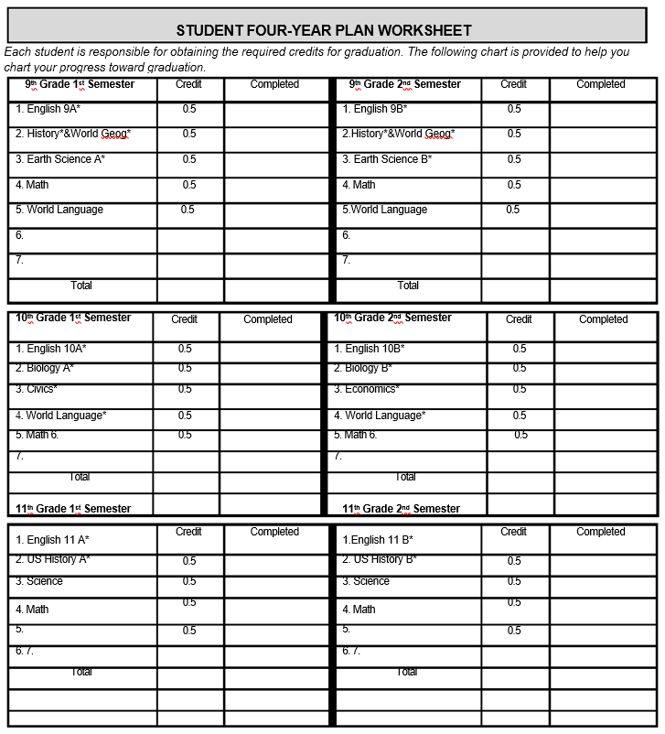

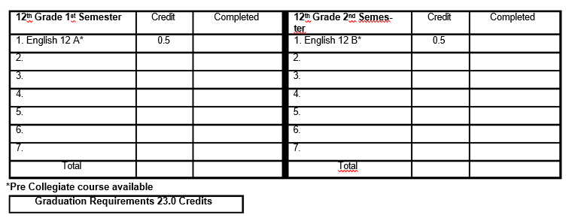

ENGLISH
English 9  Course Code:  01001-A00 / 01001-B00  NCAA Approved  Prerequisite: None  Credit Type: English  Grade: 9 Full Year | English/Language Arts I (9th grade) courses build upon students' prior knowledge of grammar, vocabulary, word usage, and the mechanics of writing and usually include the four aspects of language use: reading, writing, speaking, and listening. Typically, these courses introduce and define various genres of literature, with writing exercises often linked to reading selections
Pre Collegiate English 9  Course Code:  01001-AH00 / 01001-BH00  NCAA Approved  Prerequisite: Instructor Approval  Credit Type: English  Grade: 9 Full Year | English/Language Arts I (9th grade) courses build upon students' prior knowledge of grammar, vocabulary, word usage, and the mechanics of writing and usually include the four aspects of language use: reading, writing, speaking, and listening. Typically, these courses introduce and define various genres of literature, with writing exercises often linked to reading selections. The course prepares students for advanced course work and engages students in enrichment opportunities. Rigor is demonstrated through sophistication and acceleration in terms of thought-provoking learning activities, challenging assessments, and more complex text/materials. Diverse interests, cultures, perspectives, learning styles, and intelligences are cultivated and higher level critical and creative thinking skills such as interpretation, problem-solving, investigation, and logic are emphasized throughout the course.
English 10  Course Code:  01002-A00 / 01002-B00  NCAA Approved  Prerequisite: English 9  Credit Type: English  Grade: 10 Full Year | English/Language Arts II (10th grade) courses usually offer a balanced focus on composition and literature. Typically, students learn about the alternate aims and audiences of written compositions by writing persuasive, critical, and creative multi-paragraph essays and compositions. Through the study of various genres of literature, students can improve their reading rate and comprehension and develop the skills to determine the author's intent and theme and to recognize the techniques used by the author to deliver his or her message.
Pre Collegiate English 10  Course Code:  01002-AH0 / 01002-BH0  NCAA Approved  Prerequisite: Instructor Approval  Credit Type: English  Grade: 10 Full Year | English/Language Arts II (10th grade) courses usually offer a balanced focus on composition and literature. Typically, students learn about the alternate aims and audiences of written compositions by writing persuasive, critical, and creative multi-paragraph essays and compositions. Through the study of various genres of literature, students can improve their reading rate and comprehension and develop the skills to determine the author's intent and theme and to recognize the techniques used by the author to deliver his or her message. The course prepares students for advanced course work and engages students in enrichment opportunities. Rigor is demonstrated through sophistication and acceleration in terms of thought-provoking learning activities, challenging assessments, and more complex text/materials. Diverse interests, cultures, perspectives, learning styles, and intelligences are cultivated and higher level critical and creative thinking skills such as interpretation, problem-solving, investigation, and logic are emphasized throughout the course.
English 11  Course Code:  01003-A00 / 01003-B00  NCAA Approved  Prerequisite: English 9 and 10  Credit Type: English  Grade: 11 Full Year | English/Language Arts III (11th grade) courses continue to develop students' writing skills, emphasizing clear, logical writing patterns, word choice, and usage, as students write essays and begin to learn the techniques of writing research papers. Students continue to read works of literature, which often form the backbone of the writing assignments. Literary conventions and stylistic devices may receive greater emphasis than in previous courses.
English 12  Course Code:  01004-A00 / 01004-B00  NCAA Approved  Prerequisite: English 9,10 and 11  Credit Type: English  Grade: 12 Full Year | English/Language Arts IV (12th grade) courses blend composition and literature into a cohesive whole as students write critical and comparative analyses of selected literature, continuing to develop their language arts skills. Typically, students primarily write multi-paragraph essays, but they may also write one or more major research papers.
English 12 - Research/Tech  Course Code:  01105G05012 / 01105G05022  Prerequisite: English 9,10 and 11  Credit Type: CTE/English  Grade: 12 Full Year | Research/Technical Writing classes prepare students to write research papers and/or technical reports. These classes emphasize researching (primary and secondary sources), organizing (material, thoughts, and  arguments), and writing in a persuasive or technical style.  NOT OFFERED FOR 2022-2023
AP English Language  Course Code:  01005-A00 / 01005-B00  NCAA Approved  Prerequisite: Completion of AP Re-  quest form and Instructor Approval  Credit Type: English Language Arts  Fee: $93.00* plus textbook  Grade: 11, 12 Full Year | Following the College Board's suggested curriculum designed to parallel college-level English courses, AP English Literature and Composition courses enable students to develop critical standards for evaluating literature. Students study the language, character, action, and theme in works of recognized literary merit; enrich their understanding of connotation, metaphor, irony, syntax, and tone; and write compositions of their own (including literary analysis, exposition, argument, narrative, and creative writing). Students are responsible for purchasing the course-approved text (see AP teacher for details). Students must pay a $93 exam fee refundable after taking the AP exam in May.
AP English Literature and Comp  Course Code:  01006-A00 / 01006-B00  NCAA Approved  Prerequisite: Completion of AP Re-  quest form and Instructor Approval  Credit Type: English Language Arts  Fee: $93.00* plus textbook  Grade:12 Full Year | Following the College Board's suggested curriculum designed to parallel college-level English courses, AP English Literature and Composition courses enable students to develop critical standards for evaluating literature. Students study the language, character, action, and theme in works of recognized literary merit; enrich their understanding of connotation, metaphor, irony, syntax, and tone; and write compositions of their own (including literary analysis, exposition, argument, narrative, and creative writing).  Students are responsible for purchasing the course-approved text (see AP teacher for details). *Students must pay a $93 exam fee refundable after taking the AP exam in May.
English Composition I and English Composition II (Aims ENG 1021/1022)  Course Code:  NCAA Approved  Prerequisite: AP English Language and Composition as a junior or by instructor approval  Credit Type: English Language Arts  Fee: to be determined plus purchase of required texts; $260 charged if student does not receive a C or higher  Grade: 12 Full Year | These classes serve as an opportunity for students to receive college credit through Aims at FLHS. ENG1021 will be offered first semester; ENG 1022 will be offered second semester.  ENG 1021 - English Composition I [CO1]  Emphasizes the planning, writing, and revising of compositions, including the development of critical and logical thinking skills. This course includes a wide variety of compositions that stress analytical, evaluative, and persuasive/argumentative writing.  ENG 1022 - English Composition II [CO2]  Expands and refines the objectives of English Composition I. Emphasizes critical/logical thinking and reading, problem definition, research strategies, and writing analytical, evaluative, and/or argumentative compositions.

ENGLISH/LANGUAGE ARTS ELECTIVES *additional fees may apply
Public Speaking  Course Code:  01151-000  NCAA Approved  Prerequisite: None  Credit Type: Elective  Fee: None  Grade: 9, 10, 11, 12 One Semester | Public Speaking courses enable students, through practice, to develop skills that can be used in a variety of speaking situations (such as small and large group discussions, delivery of lectures or speeches in front of audiences, and so on). Course topics may include (but are not limited to) research and organization, writing for verbal delivery, stylistic choices, visual and presentation skills, analysis and critique, and development of self-confidence.
Literature (Science Fiction and Mythology)  Course Code:  01053-000  Prerequisite: None  Credit Type: Elective  Fee: None  Grade: 11, 12 One Semester | Literature courses offer the opportunity for students to study and reflect upon the themes presented in the body of literature being presented. Students improve their critical—thinking skills as they determine the underlying assumptions and values within the reading selection and as they understand how the work reflects society's problems and culture. Oral discussion is an integral part of literature courses, and written compositions are often required. Literature courses may survey representative works, reflect a particular genre or a specific theme, or survey works of a particular time or people.
Creative Writing  Course Code:  01104-000  NCAA Approved  Prerequisite: None  Credit Type: Language Arts - Elective  Fee: None  Grade: 10, 11, 12 One Semester | Creative Writing courses offer students the opportunity to develop and improve their technique and individual style in poetry, short story, drama, essays, and other forms of prose. The emphasis of the courses is on writing; however, students may study exemplary representations and authors to obtain a fuller appreciation of the form and craft. Although most creative writing classes cover several expressive forms, others concentrate exclusively on one particular form (such as poetry or playwriting).
Literature Circles  Course Code:  01053-000  Prerequisite: None  Credit Type: Language Arts - Elective  Fee: None  Grade: 10, 11, 12 One Semester | The Literature Circle course develops students' literacy skills by collaborating in literature circles, socratic seminars, and discussion groups with extensive practice in reading, writing, listening, and speaking. With a focus on applying texts’ central ideas and symbols to the real world, students will work in groups to develop reading comprehension, vocabulary, and critical thinking skills. The texts range from fiction, memoirs, poetry, and nonfiction.
Strategic Reading  Course Code:  01066-000  Prerequisite: Intervention Team  Recommendation  Credit Type: Elective  Fee: None  Grade: 9, 10, 11, 12 Full Year | Strategic Reading courses are intended to improve a student's vocabulary, critical-thinking and analysis skills, or reading rate and comprehension level. Although these courses typically emphasize works of fiction, they may also include works of nonfiction (including textbooks). Strategic Reading courses often have a time-management focus, offering strategies for note-taking or for understanding and evaluating the important points of a text.  NOT OFFERED FOR 2022-2023

MATHEMATICS
Algebra I  Course Code:  02052-A00 / 02052-B00  NCAA Approved  Prerequisite: Instructor Approval  Credit Type: Mathematics - Algebra I  Fee: None  Grade: 9 Full Year | Algebra I meets the first year math requirement for FLHS graduation requirements. Algebra I courses include the study of properties and operations of the real number system; evaluating rational algebraic expressions; solving and graphing first degree equations and inequalities; translating word problems into equations; operations with and factoring of polynomials; and solving simple quadratic equations.
Pre Collegiate Algebra I  Course Code:  02052-AH0 / 02052-BH0  NCAA Approved  Prerequisite: Instructor Approval  Credit Type: Mathematics - Algebra I  Fee: None  Grade: 9 Full Year | This course follows the district approved Algebra curriculum and counts as the first year of graduation requirements. Assessment is used to determine students' prior knowledge of Colorado 9 grade standards and instruction is differentiated based on the needs of the students. Topics include: properties and operations of the real number system including irrational numbers, proportional reasoning, solving and graphing first degree equations, inequalities and systems of linear equations, simplifying and factoring polynomials and solving simple quadratic equations. An emphasis is placed on analyzing situations verbally, numerically, graphically and symbolically. Students use technology and higher level critical thinking skills to investigate and explore mathematical ideas and relationships and develop multiple strategies for analyzing complex situations.
Geometry  Course Code:  02072-A00 / 02072-B00  NCAA Approved  Prerequisite: Instructor Approval  Credit Type: Mathematics - Geometry or Higher  Fee: None  Grade: 9, 10 Full Year | Geometry meets the 2nd year math requirement for FLHS graduation requirements. Geometry courses, emphasizing an abstract, formal approach to the study of geometry, typically include topics such as properties of plane and solid figures; deductive methods of reasoning and use of logic; geometry as an axiomatic system including the study of postulates, theorems, and formal proofs; concepts of congruence, similarity, parallelism, perpendicularity, and proportion; and rules of angle measurement in triangles.
Pre Collegiate Geometry  Course Code:  02072-AH0 / 02072-BH0  NCAA Approved  Prerequisite: Instructor Approval  Credit Type: Mathematics - Geometry  or Higher  Fee: None  Grade: 9, 10 Full Year | This course meets 10th grade Colorado standards by following the district approved Geometry curriculum and counts as second year of graduation requirements. This course develops the structure of Euclidean geometry and applies the resulting theorems and formulas to address meaningful problems. It includes properties of plane and solid figures; deductive methods of reasoning and use of logic; geometry as an axiomatic system including the study of postulates, theorems and proofs; concepts of congruence, similarity, parallelism, perpendicularity, and proportion; rules of angle measurement in triangles and concepts of coordinate geometry and trigonometry. Dynamic geometry software, compass and straightedge, and other tools are used to investigate and explore mathematical ideas and relationships and to develop multiple strategies for analyzing complex situations.  The pre-collegiate course prepares students for advanced course work and engages students in enrichment opportunities. Rigor is demonstrated through sophistication and acceleration in terms of thought-provoking learning activities, challenging assessments, and more complex text/materials. Diverse interests, cultures, perspectives, learning styles, and intelligences are cultivated and higher level critical and creative thinking skills such as interpretation, problem-solving, investigation, and logic are emphasized throughout the pre-collegiate course.
Geometry Principles  Course Code:  02072G05034 / 02072G05044  Prerequisite: Instructor Approval  Credit Type: Mathematics -  Geometry or Higher  Fee: None  Grade: 11, 12 Full year | This course meets 10th grade Colorado standards and covers the same content as the district approved Geometry curriculum. This course counts as a second year of graduation requirement. Students continue their pursuit of formal mathematics using geometry concepts, properties, and relationships in problem solving within the context of the construction industry. The emphasis is on using experimentation and inductive reasoning to construct geometric concepts, discover geometric relationships, and formulate conjectures. Deductive logic is employed to construct informal logical arguments and proofs. Topics include: logic, properties of triangles, parallel and perpendicular lines, congruence, similarity, coordinate geometry, area, volume, properties for circles and introductory trigonometry. Technology is emphasized through the use of graphing calculators and software applications. Students apply mathematical skills and make meaningful connections to life's experiences.  NOT OFFERED FOR 2022-2023
Algebra II  Course Code:  02056-A00 / 02056-B00  NCAA Approved  Prerequisite: Instructor Approval  Credit Type: Mathematics - Geometry  or Higher  Fee: *  Grade: 10 ,11, 12 Full Year | Algebra II course topics typically include field properties and theorems; set theory; operations with rational and irrational expressions; factoring of rational expressions; in-depth study of linear equations and inequalities; quadratic equations; solving systems of linear and quadratic equations;  graphing of constant, linear, and quadratic equations; properties of higher degree equations; and operations with rational and irrational exponents.  *Students are required to provide their own graphing calculator.
Pre Collegiate Algebra II  Course Code:  02056-AH0 / 02056-BH0  NCAA Approved  Prerequisite: Instructor Approval  Credit Type: Mathematics - Geometry  or Higher  Fee: *  Grade: 10, 11, 12 Full Year | This course follows the Algebra 2 district approved curriculum and counts as a third year of graduation requirements. Algebra 2 topics include operations with rational and irrational expressions, in-depth study of linear equations and inequalities, analyzing and solving quadratic functions including complex numbers, solving systems of linear and quadratic equations, properties of higher degree equations, and operations with rational and irrational exponents. Students investigate and solve linear piecewise, absolute value, cubic, radical, exponential, logarithmic, and rational functions algebraically, numerically, and graphically, with and without a graphing calculator.  Students analyze data and develop mathematical models to address real world problem situations. The course prepares students for advanced course work and engages students in enrichment opportunities. Rigor is demonstrated through sophistication and acceleration in terms of thought-provoking learning activities, challenging assessments, and more complex text/materials. Diverse interests, cultures, perspectives, learning styles, and intelligences are cultivated and higher level critical and creative thinking skills such as interpretation, problem-solving, investigation, and logic are  emphasized throughout the pre-collegiate course.  *Students are required to provide their own graphing calculator.
Algebra II Process Science  Course Code:  02069G05034 / 02069G05044  Prerequisite: Instructor Approval  Credit Type: Mathematics -  Geometry or Higher  Fee: None  Grade: 11,12 Full Year | This course follows the 11th grade district approved curriculum and counts as the third year of graduation requirements for math. The main focus of this course is to connect and extend algebra and geometry concepts to other functions and systems of equations. Students continue their pursuit  of formal mathematics within a context of process sciences. The classroom-ready lesson plans are built around the 11th grade district approved curriculum. ACT and Accuplacer concepts and skills are illustrated in process technology which involves the production of consumer goods from  raw material. Students participate in rigorous analysis of mathematics designed to facilitate the creation of products by mechanically, physically, and/or chemically changing raw material monitored and controlled by process technicians.  NOT OFFERED FOR 2022-2023
MATHEMATICS - ELECTIVES *=additional fees may apply
Pre-Calculus  Course Code:  02110-A00 / 02110-B00  NCAA Approved  Prerequisite: Instructor Approval  Credit Type: Mathematics - Geometry  or Higher  Fee: *  Grade: 11, 12 Full Year | Pre-Calculus courses combine the study of Trigonometry, Elementary Functions, Analytic Geometry, and Math Analysis topics as preparation for calculus. Topics typically include the study of complex numbers; polynomial, logarithmic, exponential, rational, right trigonometric, and circular functions, and their relations, inverses and graphs; trigonometric identities and equations and solutions of right and oblique triangles.  *Students are required to provide their own graphing calculator.
AP Statistics  Course Code:  02203-A00 / 02203-B00  NCAA Approved  Prerequisite: "D" or higher in  Geometry or Geometry Principles  Credit Type: Mathematics - Geometry  or Higher  Fee: None  Grade: 11, 12 Full Year | This full year course provides a means by which the student can become a more effective communicator through the study of probability and statistics. It focuses deeply on descriptive statistics, with an introduction to inferential statistics. Topics include sample spaces, measures of central tendency, normal curve, sampling techniques, standard deviation, t-test, correlation coefficient, techniques for determining probabilities, and matrix algebra. Students will be able to conduct a hypothesis test for a population mean, a population proportion, and a population variance; construct confidence intervals for population parameters; and conduct regression analysis for variables. Technology will be emphasized through the use of graphing calculators.  NOT OFFERED FOR 2022-2023
Calculus  Course Code:  02124-A00 / 02124-B00  NCAA Approved  Prerequisite: Instructor Approval and “C” or higher in Pre-Calculus  Credit Type: Mathematics - Geometry  or Higher  Fee: *  Grade: 12 Full Year | Calculus provides students with an intuitive understanding of the concepts of calculus and experience with its methods and applications. This course introduces calculus and includes the following topics: elementary functions; properties of functions and their graphs; limits and continuity; differential  calculus (including definition of the derivative, derivative formulas, theorems about derivatives, geometric applications, optimization problems, and rate-of change problems); and integral calculus ( including anti-derivatives, the definite integral and application of integrals). Students must have earned a "C" grade or better in Algebra I, Geometry, Algebra II, Trigonometry and Pre-Calculus. Course grades, GPA, attendance, class performance, testing (PARCC, ACT, SAT), and teacher recommendation may also be considered.  *Students are required to provide their own graphing calculator.
Probability and Statistics  Course Code:  02201-A00 / 02201-B00  NCAA Approved  Prerequisite: Algebra 2  Credit Type: Mathematics - Geometry or Higher  Fee: None  Grade: 11, 12 Full year | Probability and Statistics courses introduce the study of likely events and the analysis interpretation, and presentation of quantitative data. Course topics generally include basic probability and statistics: discrete probability theory, odds and probabilities, probability trees, populations and samples,  frequency tables, measures of central tendency, and presentation of data (including graphs). Course topics may also include normal distribution and measures of variability.

SCIENCE *=additional fees may apply
Earth Science  Course Code:  03001-A00 / 03001-B00  NCAA Approved  Prerequisite: None  Credit Type: Science  Fee: None  Grade: 9 Full Year | Earth Science courses offer insight into the environment on earth and the earth's environment in space. While presenting the concepts and principles essential to students' understanding of the dynamics and history of the earth, these courses usually explore oceanography, geology, astronomy,  meteorology, and geography.
Biology I  Course Code:  03051-A00 / 03051-B00  NCAA Approved  Prerequisite: Earth Science  Credit Type: Science  Fee: $10  Grade: 10 Full Year | Biology courses are designed to provide information regarding the fundamental concepts of life and life processes. These courses include (but are not restricted to) such topics as cell structure and function, general plant and animal physiology, genetics, and taxonomy.
Pre Collegiate Biology I  Course Code:  03051-AH0 / 03051- BH0  NCAA Approved  Prerequisite: Honors Earth Science;  Instructor approval  Credit Type: Science  Fee: $10  Grade: 10 Full Year | Biology is designed to provide information regarding the fundamental concepts of life and life processes. These courses include (but are not restricted to) such topics as cell structure and function, general plant and animal physiology, genetics, and taxonomy. The pre-collegiate course prepares students for advanced course work and engages students in enrichment opportunities. Rigor is demonstrated through sophistication and acceleration in terms of thought-provoking learning activities, challenging assessments, and more complex text/materials. Diverse interests, cultures, perspectives, learning styles, and intelligences are cultivated and higher level critical and creative thinking skills such as interpretation, problem-solving, investigation, and logic are emphasized throughout the pre-collegiate course.
Chemistry I  Course Code:  03101-A00/03101-B00  NCAA Approved  Prerequisite: Biology  Credit Type: Science  Fee: None  Grade: 10,11,12 Full Year | Chemistry courses involve studying the composition, properties, and reactions of substances. These courses typically explore such concepts as the behaviors of solids, liquids, and gases; acid/base and oxidation/reduction reactions; and atomic structure. Chemical formulas and equations and nuclear reactions are also studied.
Pre Collegiate Chemistry I  Course Code:  03101-AH0/03101-BHO  NCAA Approved  Prerequisite: Biology or AP Environmental  Credit Type: Science  Fee: None  Grade: 10,11,12 One Year | Chemistry courses involve studying the composition, properties, and reactions of substances. These courses typically explore such concepts as the behaviors of solids, liquids, and gases; acid/base and oxidation/reduction reactions; and atomic structure. Chemical formulas and equations and nuclear reactions are also studied.
Pre Collegiate Physics I  Course Code:  03151-AH0/03151-BH0  NCAA Approved  Prerequisite: Chemistry I & Algebra II with C or better.  Credit Type: Science  Fee: $5  Grade: 10, 11, 12 One Year | This Advanced College Preparatory course involves the study of scientific measurement, scientific method, Newton's laws of motion, Linear Motion, gravitational motion, angular motion, momentum, energy, potential and kinetic energy, temperature, heat and expansion, heat transfer, thermodynamics, and vibrations & waves, light, electricity (Colorado Academic Science Standard  The pre-collegiate course prepares students for advanced course work and engages students in enrichment opportunities. Rigor is demonstrated through sophistication and acceleration in terms of thought-provoking learning labs and activities, challenging assessments, and more complex text/materials.
SCIENCE ELECTIVES *=additional fees may apply
Astronomy  Course Code:  03004-A00/03004-B00  NCAA Approved  Prerequisite: Algebra I  Credit Type: Science - elective  Fee: None  Grade: 10,11, 12 One Year | Astronomy courses offer students the opportunity to study the solar system, stars, galaxies, and interstellar bodies. These courses usually introduce and use astronomic instruments and typically explore theories regarding the origin and evolution of the universe, space, and time.
Anatomy & Physiology  Course Code:  03053-A00 / 03053-B00  NCAA Approved  Prerequisite: Earth Science and Biology  Credit Type: Science-elective  Fee: $10  Grade: 11,12 Full Year | Usually taken after a comprehensive initial study of biology, Anatomy and Physiology courses present the human body and biological systems in more detail. In order to understand the structure of the human body and its functions, students learn anatomical terminology, study cells and tissues, explore functional systems (skeletal, muscular, circulatory, respiratory, digestive, reproductive, nervous, and so on), and may dissect mammals.
AP Biology  Course Code:  03056-A00 / 03056-B00  NCAA Approved  Prerequisite: Biology 1 or AP  Environmental Science  Credit Type: Science-elective  Fee: $93.00* plus textbook  Grade: 10-12 Full Year | The AP Biology course is an introductory college-level biology course. Students cultivate their understanding of biology through inquiry-based investigations as they explore the following topics: evolution, cellular processes, energy and communication, genetics, information transfer, ecology, and interactions.  Students are responsible for purchasing the course approved text (see AP teacher for details). *Students must pay a $93 exam fee.
AP Chemistry  Course Code:  03106-A00 / 03106-B00  NCAA Approved  Prerequisite: Completion of AP Request form; Chemistry I and Algebra  II with a C or better.  Credit Type: Science-elective  Fee: $93.00* plus textbook  Grade: 11,12 Full Year | Following the curricula recommended by the College Board, AP Chemistry courses usually follow high school chemistry and second-year algebra. Topics covered may include atomic theory and structure; chemical bonding; nuclear chemistry; states of matter; and reactions (stoichiometry, equilibrium, kinetics, and thermodynamics). AP Chemistry laboratories are equivalent to those of typical college courses.  Students are responsible for purchasing the course approved text (see AP teacher for details). *Students must pay a $93 exam fee.  NOT OFFERED FOR 2023-2024
AP Environmental Science  Course Code:  03207-A00 / 03207-B00  NCAA Approved  Prerequisite:  Credit Type: Science-elective  Fee: $93.00* plus textbook  Grade: 9,10,11,12 Full Year | The AP Environmental Science course is designed to engage students with the scientific principles, concepts, and methodologies required to understand the interrelationships within the natural world. The course requires that students identify and analyze natural and human-made environmental problems, evaluate the relative risks associated with these problems, and examine alternative solutions for resolving or preventing them. Environmental science is interdisciplinary, embracing topics from geology, biology, environmental studies, environmental science, chemistry, and geography.  Students are responsible for purchasing the course approved text (see AP teacher for details). *Students must pay a $93 exam fee.

SOCIAL STUDIES
World History  Course Code:  04052-A00/04052—B00  NCAA Approved  Prerequisite: None  Credit Type: Social Studies  Fee: None  Grade: 9 Full Year | In addition to covering the objectives of World History - Overview courses, World History courses provide an overview of World History. These courses are often developed in response to increased national concern regarding the importance of geography, and they explore geographical concepts.
Pre Collegiate World History  Course Code:  04052-AH0 / 04052-BH0  NCAA Approved  Prerequisite: None  Credit Type: Social Studies-Civics  Fee: none  Grade: 9 Full Year | In addition to covering the objectives of World History overview courses. World History and Geography courses provide an overview of World History. These courses are often developed in response to increased national concern regarding the importance of geography, and explore geographical concepts.  The course prepares students for advanced course work and engages students in enrichment opportunities. Rigor is demonstrated through sophistication and acceleration in terms of thought-provoking learning activities, challenging assessments, and more complex text/materials. Diverse interests, cultures, perspectives, learning styles, and intelligences are cultivated and higher level critical and creative thinking skills such as interpretation, problem-solving, investigation, and logic are emphasized throughout the course.
Geography  Course code:  NCAA Approved  Prerequisite: None  Credit Type: Social Studies  Fee: None  Grade: | This course is designed for students to explore geography’s impact on the globe. Students will explore the historic, geographic, economic and civic movements that have taken place across the globe. Classes will also analyze primary and secondary sources, graphs, charts, and infographics to determine the impact Geographic themes have on people, nations, government decisions, economic decisions, the environment, changes in culture, and globalization.
Civics  Course Code:  04161-000  NCAA Approved  Prerequisite: None  Credit Type: Social Studies  Fee: none  Grade: 10 One Semester | Civics courses examine the general structure and functions of American systems of government, the roles and responsibilities of citizens to participate in the political process, and the relationship of the individual to the law and legal system. These courses do not typically delve into the same degree of detail on constitutional principles or the role of political parties and interest groups as do comprehensive courses in the U.S. Government.
Pre Collegiate Civics  Course Code:  04161-AH0  NCAA Approved  Prerequisite: None  Credit Type: Social Studies-Civics  Fee: none  Grade: 10 One Semester | This required Pre Collegiate Civics course (or its equivalent Civics) examines the general structure and functions of American systems of government, the roles and responsibilities of citizens to participate in the political process, and the relationship of the individual to the law and legal system. These courses do not typically delve into the same degree of detail on constitutional principles or the role of political parties and interest groups as do comprehensive courses in the U.S. Government.  The course prepares students for advanced course work and engages students in enrichment opportunities. Rigor is demonstrated through sophistication and acceleration in terms of thought-provoking learning activities, challenging assessments, and more complex text/materials. Diverse interests, cultures, perspectives, learning styles, and intelligences are cultivated and higher level critical and creative thinking skills such as interpretation, problem-solving, investigation, and logic are emphasized throughout the course.
Economics  Course Code:  04201-000  NCAA Approved  Prerequisite: None  Credit Type: Social Studies  Fee: none  Grade: 10 or 11 One Semester | Economics courses provide students with an overview of economics with primary emphasis on the principles of microeconomics and the U.S. economic system. These courses may also cover topics such as principles of macroeconomics, international economics, and comparative economics. Economic principles may be presented in formal theoretical contexts, applied contexts, or both.
Pre-Collegiate Economics  Course Code:  04201-BH0  NCAA Approved  Prerequisite: None  Credit Type: Social Studies  Fee: none  Grade: 10 or 11 One Semester | This required Pre Collegiate Economics course (or its equivalent Economics) provides students with an overview of economics with primary emphasis on the principles of microeconomics and the U.S. economic system. These courses may also cover topics such as principles of macroeconomics, international economics, and comparative economics. Economic principles may be presented in formal theoretical contexts, applied contexts, or both.  The course prepares students for advanced course work and engages students in enrichment opportunities. Rigor is demonstrated through sophistication and acceleration in terms of thought-provoking learning activities, challenging assessments, and more complex text/materials. Diverse interests, cultures, perspectives, learning styles, and intelligences are cultivated and higher level critical and creative thinking skills such as interpretation, problem-solving, investigation, and logic are emphasized throughout the course.
Modern U.S. History  Course Code:  04103-A00 / 04103-B00  NCAA Approved  Prerequisite: None  Credit Type: Social Studies  Fee: none  Grade: 11 Full Year | Modern U.S. History courses examine the history of the United States from the Civil War or Reconstruction era (some courses begin at a later period) through the present time. These courses typically include a historical review of political, military, scientific, and social developments.
AP U.S. History  Course Code:  04104-A00 / 04104-B00  NCAA Approved  Prerequisite: Teacher Approval and a  B or above in Pre-Collegiate, World  History and Civics/Economics  Credit Type: Social Studies  Fee: $93.00 plus textbook  Grade: 11, 12 Full Year | Following the College Board's suggested curriculum designed to parallel college-level U.S. History courses, AP U.S. History courses provide students with the analytical skills and factual knowledge necessary to address critical problems and materials in U.S. history. Students learn to assess historical materials and to weigh the evidence and interpretations presented in historical scholarship. The course examines the discovery and settlement of the New World through the recent past.  Students are responsible for purchasing the course approved text (see AP teacher for details). *Students must pay a $93 exam fee.
AP World History  Course Code:  04057-A00 / 04057-B00  NCAA Approved  Prerequisite: None  Credit Type: Social Studies  Fee: $93.00 plus textbook  Grade: 11, 12 Full Year | Following the College Board's suggested curriculum designed to parallel college-level World History courses, AP World History courses examine world history from 8000 BCE to the present with the aim of helping students develop a greater understanding of the evolution of global processes and  contracts and how different human societies have interacted. These courses highlight the nature of changes in an international context and explore their causes and continuity.  Students are responsible for purchasing the course approved text (see AP teacher for details). *Students must pay a $93 exam fee.  NOT OFFERED FOR 2022-2023

SOCIAL STUDIES ELECTIVES
Psychology  Course Code:  04254-A00 / 04254-B00  NCAA Approved  Prerequisite: Instructor Approval  Credit Type: Social Studies  Fee: None  Grade: 10,11, 12 Full Year | Psychology courses introduce students to the study of individual human behavior. Course content typically includes (but is not limited to) an overview of the field of psychology, topics in human growth and development, personality and behavior, and abnormal psychology.
AP Psychology  Course Code:  04256-A00 / 04256-B00  NCAA Approved  Prerequisite: Completion of AP Re-  quest form and Intro to Psych  Credit Type: Social Studies - Elective  Fee: $25.00 plus textbook  Grade: 11,12 Full Year | Following the College Board's suggested curriculum designed to parallel a college-level psychology course, AP Psychology courses introduce students to the systematic and scientific study of the behavior and mental processes of human beings and other animals, expose students to each major subfield within psychology, and enable students to examine the methods that psychologists use in their science and practice.
The History of Latin America  Course Code:  00000-000 / 00000-000  NCAA Approved  Prerequisite: World History,Economics (Personal Finance), Civics  Credit Type: Social Studies  Fee: Unknown  Grade: 11, 12 Semester (half year). | The History of Latin America (1800-present) serves as a brief overview of the political, economic, and social developments of Central and South American countries. This course will be divided into a series of respective lens that will focus on each respective development and interaction. Latin History will examine consequential events in the development of the people in the region while focusing on processes and interactions between people that have perpetuated future developments. Topics associated with this include but are limited to Latin American revolutions, history of the Latin American relations (e.g. borderlands of Mexico and the United States), cultural interactions between Latin American peoples). Students will use their previous social study skills of inquiry, analysis, project based learning, and collaboration to overview reach respective developments.  1800 present day.  Students are _______________for purchasing the course approved text (see teacher for details).  Offered for the 2023-2024 School Year
Personal Finance  Course Code:  04249-000  Prerequisite: None  Credit Type: Social Studies  Fee: None  Grade: 12 One Semester | Personal Finance is a course designed to help students understand the impact of individual choices revolved around money. Topics covered will include, income, money management, saving and spending, credit, financial services, and investing and retirement.
Link Crew  Course Code:  Prerequisite: Application process  Credit Type: Elective  Fee: None  Grade: 10, 11, 12 One Year | The Link Crew class is designed to teach 10th, 11th, and 12th graders how to become Link Crew Leaders. In doing so, these leaders will be trained to mentor freshmen. This mentorship is designed to help freshmen students transition from Middle School to High School. This transition begins with a powerful orientation day that makes freshmen excited and proud to be attending Ft. Lupton. This orientation also allows them to begin developing relationships and strategies needed to be successful in a high school environment. After orientation, the Link Crew program continues to support freshmen success throughout the school year. Link Crew Leaders will be expected to be available the last week of summer to prepare for the freshmen orientation. Candidates must also be available throughout the school year to help out with school functions. If you are interested in becoming a link crew leader applications will need to be completed and turned into Mr. Hickman by May 1st.
Student Government  Course Code: 22103-A00 / 22103-B00  Prerequisite: By Invitation Only  Credit Type: Elective  Fee: None  Grade: 10, 11, 12 One Year | Fort Lupton HS Student Government is a once a day offered course where selected students work together in an effort to plan and organize opportunities for their constituents, the student body. In addition to the planning of events, Student Government encourages students to perfect the skills of collaboration, leadership, and project planning with the sole goal of unifying our school in an effort to better serve our community. Lastly, students in Student Government are expected and required to participate in service learning & community activities in an effort to further bridge the gap between school and community.

WORLD LANGUAGES *=additional fees may apply
Spanish I  Course Code:  06101-A00 / 06101-B00  NCAA Approved  Prerequisite: None  Credit Type: World Language  Fee: None  Grade: 9, 10, 11, 12 Full Year | Designed to introduce students to Spanish language and culture, Spanish I courses emphasize basic grammar and syntax, simple vocabulary, and the spoken accent so that students can read, write, speak, and understand the language at a basic level within predictable areas of need, using customary courtesies and conventions. Spanish culture is introduced through the art, literature, customs, and history of Spanish-speaking people.
Spanish II  Course Code:  06102-A00 / 06102-B00  NCAA Approved  Prerequisite: Spanish I  Credit Type: World Language  Fee: None  Grade: 9, 10, 11, 12 Full Year | Spanish II courses build upon skills developed in Spanish I, extending students' ability to understand and express themselves in Spanish and increasing their vocabulary. Typically, students learn how to engage in discourse for informative or social purposes, write expressions or passages that show understanding of sentence construction and the rules of grammar, and comprehend the language when spoken slowly. Students usually explore the customs, history, and art forms of Spanish-speaking people to deepen their understanding of the culture(s).
Spanish for Native Speakers  Course Code:  06106-A00 / 06106-B00  Prerequisite: None  Credit Type: World Language  Fee: None  Grade: 9, 10, 11, 12 Full Year | Spanish for Native Speakers courses support, reinforce and expand students' knowledge of their own tongue. Because students understand at least the rudiments and structure of the language and have a working vocabulary (to a greater or lesser degree), Spanish for Native Speakers courses often move faster than do regular Spanish Foreign Language courses and emphasize literary development (with a study of literature and composition). These courses may also include the culture or history of the people and introduce translation skills.
Spanish III  Course Code:  06103-A00 / 06103-B00  NCAA Approved  Prerequisite: Spanish I & II with C or  better &/or pre-test/instructor  approval  Credit Type: World Language  Fee: None  Grade: 10, 11, 12 Full Year | Spanish III courses focus on having students express increasingly complex concepts both verbally and in writing while showing some spontaneity. Comprehension goals for students may include attaining more facility and faster understanding when listening to the language spoken at normal rates, being able to paraphrase or summarize written passages, and conversing easily within limited situations.
AP Spanish Language  Course Code:  06112-A00 / 06112-B00  NCAA Approved  Prerequisite: Completion of AP  Request form  Credit Type: World Language  Fee: $93.00 plus text book  Grade: 11, 12 Full Year | Designed by the College Board to parallel third-year college-level courses in Spanish Composition and Conversation, AP Spanish Language courses build upon prior knowledge and develop students' ability to understand others and express themselves (in Spanish) accurately, coherently, and fluently in both formal and informal situations. Students will develop a vocabulary large enough to understand literary texts, magazine/newspaper articles, films and television productions, and so on.  Students are responsible for purchasing the course approved text (see AP teacher for details). *Students must pay a $93 exam fee.
AP Spanish Literature  Course Code:  06113-A00 / 06113-B00  NCAA Approved  Prerequisite: Completion of AP  Request form  Credit Type: World Language  Fee: $93.00* plus text book  Grade: 11, 12 Full Year | Designed by the College Board to parallel college-level Introduction to Hispanic Literature courses, AP Spanish Literature courses cover representative works from the literature of Spain and Spanish America, encompassing all genres. The courses build students' Spanish language proficiency so that they are able to read and understand moderately difficult prose and express critical opinions and literary analysis in oral and written Spanish (an ability equivalent to having completed a third-year college-level Spanish Language course).  Students are responsible for purchasing the course approved text (see AP teacher for details). *Students must pay a $93 exam fee.

Alternative Cooperative Education (ACE)
ACE Financial Literacy  Course Code:  Prerequisite: ACE Career Development 1 or Teacher approval  Credit Type: 0.5 Math / CTE  Grade: 11th, 12th Fall Semester Only | This course focuses on personal financial literacy. As developmentally appropriate, this course is designed for students to learn and practice financial literacy, decision-making, and management skills for their personal and professional lives. Students will create and modify budgets according to new circumstances. Students will be practicing basic banking activities such as check writing, debit card use, deposits and keeping track of a spending register and explore online banking and banking apps and compare and contrast several types of financial institutions. Students will examine the benefit and detriment of managing credit. Students will apply practical application of fiscal management topics such as renting vs owning, mortgage calculators, new car vs used car purchase, how to get a car loan, financial calculator use, understanding payroll deductions and benefits, income tax and filing taxes, and comparing and contrasting possibilities. Students will demonstrate knowledge of FAFSA, loans, grants scholarships and other Postsecondary financial supports. Students will examine the many ways to invest money and participate in simulations involving investing.
ACE Career Development 1: Career Planning  Course Code:  Prerequisite:  Credit Type: 0.5 Elective / CTE  Grade: 11th, 12th Fall Semester Only | This course is designed for students to create an individual, initial career plan that outlines steps to reach their career goal. Students will identify a career goal based upon the results of various assessments, i.e. interest survey, aptitude evaluation, academic skills, learning styles, work preferences, etc. Students will also investigate the training and educational requirements (academic planning & Postsecondary options) for their chosen career field. Students should be able to articulate short-term action necessary to achieve the goal(s) in their career plan; including intentional academic planning, high school choices based on self-awareness, career exploration and Postsecondary aspirations..
ACE Career Development 2  Course Code:  Prerequisite: ACE Career Development 1 or Teacher approval  Credit Type: 0.5 Elective / CTE  Grade: 11th, 12th Spring Semester Only | This course is designed to teach skills needed for entry into the workforce. Students will demonstrate successful job search strategies. Students will demonstrate employability skill ability to accurately complete job applications, write a resume, ask for letters of recommendation. Students will examine model interviews and then participate in their own interview simulations. Students will be able to advocate for accommodations or adaptations necessary to be successful on the job. Students will be knowledgeable of the environmental expectations of the workplace. Additionally, students will be introduced to personal financial literacy skills including: financial planning, budgeting, saving, credit, paycheck calculation, and taxes. Students practice appropriate communication, teamwork, problem-solving while working in a group environment.
ACE Success Foundations  Course Code:  Prerequisite: ACE Career Development 1 or Teacher approval  Credit Type: 0.5 Elective / CTE  Grade: 11th, 12th Spring Semester Only | This course focuses on personal/self-awareness. This class is designed to help students explore and develop the personal and academic skills that are foundational to successful transition into the working world. Teachers will facilitate students learning and implementing academic discipline skills, mindsets, and behaviors for successful academic course completion, and help them to identify methods for setting goals for personal improvement and continuous growth in an academic area, and explain the purpose of fundamental tools used to pursue a career path. Students will select critical thinking skills to make informed, ethical, and socially responsible choices and will also work on implementing essential routines for physical and mental health maintenance and personal safety, including emotion regulation, positive communication skills, decision-making, goal setting, time management, advocacy, problem solving, conflict resolution, self-awareness, personal responsibility, work ethic, stress management, and appropriate personal/social and conflict resolution skills. Students will investigate how all of these factors influence successful career habits. Students will also have the opportunity to determine personal interests, talents, goals and preferences for potential careers, and explore the connection between those interests and Postsecondary workforce aspirations and options.
ACE COMMUNITY WORK-BASED LEARNING  Course Code:  Prerequisite: ACE Career Development 2 or Teacher approval  Credit Type: 0.5 Elective / CTE  Grade: 11th, 12th Spring Semester Only | As developmentally appropriate, this course (or series of courses) is designed for students to enhance employment skills by participating in a community-based work experience (paid or unpaid). A training plan and evaluation (to be filled out by the supervisor/employer) will be developed listing job specific technical skills the student will learn during the experience. Hours worked will be documented. Students will demonstrate levels of self-awareness, career exploration, academic planning based off of postsecondary aspirations and realistic options, employability skills, and environmental expectations. ACE teacher serves as a coach and mentor checking in with supervisor/employer regularly.
ACE CAPSTONE/PORTFOLIO BASED/CULMINATING COURSE  Course Code:  Prerequisite: ACE Career Development 1 or Teacher approval  Credit Type: 0.5 Elective / CTE  Grade: 11th, 12th Spring Semester Only | Students critique and formulate skills to complete a multifaceted learning portfolio that serves as a culminating academic and intellectual experience for students in pathway programs. Instruction and experiences may include: topic selection, portfolio creation, community connections; employability skills such as: oral communication, public speaking, research skills, computer literacy, teamwork; the academic planning skills such as: self-sufficiency and goal setting, and; postsecondary workforce readiness skills that will help prepare them for college, modern careers, and adult life. Students will demonstrate levels of knowledge and skill for the environmental expectations of postsecondary options and intentional academic planning based on self-awareness and career exploration. This course is designed to meet or exceed the current Colorado Graduation Guideline menu option for Capstone.

ART *=additional fees may apply
Multi-Medium Foundational Art  Course Code: 05151-000  Prerequisite: None  Credit Type: 0.5 Fine Arts / Elective  Fee: $10.00*  Grade: 9, 10, 11, 12 One Semester | This foundational art class is a lively, inviting, comprehensive course for beginning level art students and those students who want to dabble in different art forms. It includes interactive activities and studio projects representing a wide variety of cultures, artistic styles, and art media. The course is designed to enrich the lives of students through discovery and creative problem solving. It is an integration of aesthetics, art criticism, art history, and hands-on studio production. Students will be introduced to Drawing, Painting, Sculpture, Textiles, Photography, and various other art forms.
Three-Dimensional Art 1  Course Code: 05154-000  Prerequisite: Recommended but not necessary "Multi-Medium Foundational Art Class"  Credit Type: 0.5 Fine Arts / Elective  Fee: $10.00*  Grade: 10, 11,12 One Semester | This course focuses on creating three-dimensional works of art out of various materials including, but not limited to, clay, metal, paper, wood, and found objects. The common concepts taught in this course are material exploration, tool familiarity, ceramics, molds and casts-\, figure molding, sewing, and textiles. Students will also explore retail and commercial possibilities for their work.
Advanced Three-Dimensional Art  Course Code: 05154-100  Prerequisite: Three-Dimensional Art 1  Credit Type: 0.5 Fine Arts / Elective  Fee: $15.00*  Grade: 10, 11,12 One Semester | Students continue to develop skills learned in their Three-Dimensional Art Class, focusing more on style development and branding.
Drawing 1  Course Code: 05156-000  Prerequisite: Recommended but not necessary "Multi-Medium Foundational Art Class"  Credit Type: 0.5 Fine Arts / Elective  Fee: $10.00*  Grade: 9, 10, 11, 12 One Semester | This course focuses on building fundamental drawing skills. Students will learn basic techniques such as shading, controlling tones, composition and drawing methods. Additionally, we learn how to see with an artist's eye and capture what we see on paper. Students learn to master basic skills and to encourage experimentation with techniques and materials, both traditional and non-traditional. You do not have to know how to draw to take this class!
Advanced Drawing  Course Code: 05156-100  Prerequisite: Drawing 1  Credit Type: 0.5 Fine Arts / Elective  Fee: $10.00*  Grade: 11, 12 One Semester | This course builds on the knowledge and skills learned in Drawing 1, and is designed to help the students find their "artistic voice". We explore personal expression while working from observation and investigating a wide range of contemporary issues and themes. Studio activities, lectures, critiques, and demonstrations are designed to help the students expand their visual understanding and develop their critical, verbal, and technical skills necessary for the creative process.
Painting 1  Course Code: 05157-000  Prerequisite: Recommended but not necessary "Multi-Medium Foundational Art Class"  Credit Type: 0.5 Fine Arts / Elective  Fee: $10.00*  Grade: 9, 10, 11, 12 One Semester | This course is a basic studio course in the media and techniques of painting. Activity will emphasize the study of color theory, structure, creativity and aesthetic values in general. A command of techniques and materials, both traditional and experimental, will be taught. Students will identify and utilize a variety of historical and contemporary painting styles and will describe and apply the elements and principles of design in paintings. Students will experiment with a variety of painting techniques to develop a working knowledge of the creative potential of each technique. You do not have to know how to paint in order to take this course!
Advanced Painting  Course Code: 05157-100  Prerequisite: Painting 1  Credit Type: 0.5 Fine Arts / Elective  Fee: $10.00*  Grade: 10, 11, 12 One Semester | This course will further develop and refine painting techniques and concepts, as well as understanding of figure painting for the purpose of artistic expression. Students will develop their own style and branding.
Jewelry 1  Course Code: 05166-000  Prerequisite: Recommended but not necessary "Multi-Medium Foundational Art Class"  Credit Type: 0.5 Fine Arts / Elective  Fee: $10.00*  Grade: 9, 10, 11, 12 One Semester | Introductory jewelry course where students learn about the history of jewelry, fabrication techniques, design fundamentals and equipment use, as well as a variety of materials to create jewelry including several types of clays, resin, and paper. This course includes classroom and studio instruction. Students create their own jewelry pieces, joining methods, metal working and finishing are also covered.
Advanced Jewelry  Course Code: 05166-100  Prerequisite: Jewelry 1  Credit Type: 0.5 Fine Arts / Elective  Fee: $10.00*  Grade: 10, 11, 12 One Semester | This course is designed to give direct practical experience in the design and fabrication of contemporary and traditional jewelry, and to hone manual and creative skills learned in Jewelry 1. The course aims to build on the student’s technical skills in jewelry design and fabrication, experience in workshop practice, use of tools and materials, and safety. Emphasis is placed on both design and craftsmanship. Students should know how to practice patience, attention, precision, and display a passion for creating new forms. Students also learn to brand their style and explore retail opportunities for their work.

ENGINEERING
Principles of Engineering & Technology  Course Code: 21004-100  Prerequisite: None  Credit Type: 0.5 CTE - Science Elective  Fee: $15  Grade: 9,10, 11 & 12th Fall Semester Only | Principles of Engineering and Technology is a foundational course in the STEM cluster for students interested in learning more about careers in engineering and technology. This course covers basic skills required for engineering and technology fields of study. Upon completion of this course, proficient students are able to identify and explain the steps in the engineering design process. Students can evaluate an existing engineering design, use fundamental sketching and engineering drawing techniques, complete simple design projects using the engineering design process, and effectively communicate design solutions to others.
Introduction to Engineering Design  Course Code: 21007-200  Prerequisite: Principles of Engineering & Technology  Credit Type: 0.5 CTE - Science Elective  Fee: $15  Grade: 9, 10, 11,& 12th Spring Semester Only | Introduction to Engineering Design is a fundamental course in the STEM pathway for students interested in developing their skills in preparation for careers in engineering and technology. The course covers essential knowledge, skills, and concepts required for postsecondary engineering and technology fields of study. Upon completion of this course, proficient students are able to describe various engineering disciplines, as well as admission requirements for postsecondary engineering and engineering technology programs in Colorado. Students will also be able to identify simple and complex machines, calculate various ratios related to mechanisms, explain fundamental concepts related to energy, understand Ohm’s Law, follow the steps in the engineering design process to complete a team project, and effectively communicate design solutions to others.
Capstone: Engineering & Technology  Course Code: 21047-3A0 and 21047-3B0  Prerequisite: Principles of Engineering & Technology, Introduction to Engineering Design  Credit Type: 1.0 CTE - Science Elective  Fee: $15  Grade: 10, 11,& 12th Full Year | This course allows for individualized, advanced, and/or cumulative work in a program of study. This work is individualized to the student within a specific program of study to allow for specialized study. It may include problem-/project-based learning or preparation for industry certification. The specific content and course design is determined by the instructor, in collaboration with the individual student.
Programming  Course Code: 10012-100  Prerequisite: None  Credit Type: 0.5 CTE - Science Elective  Fee: $15  Grade: 9, 10, 11,& 12th Semester | This course is intended to teach students the basics of computer programming. The course places emphasis on practicing standard programming techniques and learning the logic tools and methods typically used by programmers to create simple computer applications. Upon completion of this course, proficient students will be able to solve problems by planning multi step procedures; write, analyze, review, and revise programs, converting detailed information from workflow charts and diagrams into coded instructions in a computer language; and will be able to troubleshoot/debug programs and software applications to correct malfunctions and ensure their proper execution.

FAMILY AND CONSUMER SCIENCES *=additional fees may apply
Culinary Essentials  Course Code: 16052-A00 and 16052-B00  Prerequisite: None  Credit Type: 1.0 FACS / Elective  Fee: $15  Grade: 9, 10, 11, & 12th Full Year | This course introduces you to a variety of culinary skills through instruction and hands-on cooking labs. Some topics include kitchen basics, meal planning, and nutrition. Students will prepare various types of meats, pasta dishes, quick breads, and more! You will learn how to select herbs and spices to enhance flavors of foods. Apply techniques used in cake and cookie decorating. Identify the origins and prepare foods from different regions and cultures. FCCLA is an integral part of this course.
ProStart 1  Course Code: 16054-000  Prerequisite: Culinary Essentials 1  Credit Type: 1.0 FACS / Elective  Fee: $15  Grade: 10, 11, & 12th Full Year | This course from the National Restaurant Association introduces students to the world of professional cooking! Basic communication skills, safety and sanitation, food preparation, meal and menu planning, and other topics are taught in this course. FCCLA is an integral part of this course. The class will teach you basic food safety and sanitation, customer service, food preparation and employability skills. We will take exciting tours and host many great guest speakers.
ProStart 2  Course Code: 16055-000  Prerequisite: ProStart 1  Credit Type: 1.0 FACS / Elective  Fee: $15  Grade: 11 & 12th Full Year | Students will continue to be trained for employment in restaurants and hospitality. The basic skills taught in ProStart I will be reviewed and additional skills such as customer relations, accounting procedures, and more advanced food preparation skills will be taught. FCCLA is an integral part of this course. This course will train you in food preparation techniques as well as hotel/motel management skills. You will apply the knowledge, skills, and abilities that are delivered through the coursework of the Program of Study (POS).
Design Seminar  Course Code: 19249-A00  Prerequisite: None  Credit Type: 0.5 FACS / Elective  Fee: $15  Grade: 9, 10 11, & 12th Full Year | This course will give students an introduction to the elements and principles of design as seen in Interior Design, Fashion Design, and a variety of other fields. In addition, it will introduce students to the many careers that require design and allow them to analyze their own career pathways to determine where design might fit. This course is recommended as an introduction to the fashion and interior design pathway.

BUSINESS *=additional fees may apply
HSB Leadership  Course Code: 22101-A00  Prerequisite: None  Credit Type: 0.5 HSB / Elective  Fee: $15  Grade: 9th Fall Semester Only | This project-based leadership course develops student understanding and skills in such areas as communication skills, emotional intelligence, operations, and professional development. Students acquire an understanding and appreciation of the need for leadership skills. The capstone activity of the course is the implementation of a service-learning project. Throughout the course, students are presented problem-solving situations for which they must apply academic and critical-thinking skills. Formal reflection is an on-going component of the course.
HSB Wealth Management  Course Code: 12017-B00  Prerequisite: None  Credit Type: 0.5 HSB / Elective  Fee: $15  Grade: 9th Spring Semester Only | This project-based financial literacy course develops student understanding and skills in such areas as economic decision-making, time value of money, financial management, and types of investments. Students acquire an understanding and appreciation of the need for personal financial management and investing. The course content is sequenced for students to develop a full understanding of their role and responsibility in their financial future. Throughout the course, students are presented problem-solving situations for which they must apply academic and critical-thinking skills.
HSB Principles of Business  Course Code: BUS 115  Prerequisite: Must have teacher approval  Credit Type: 0.5 HSB / Elective, plus 3 AIMS  Community College Credits  Fee: $15  Grade: 10th Fall Semester Only | AIMS Community College Concurrent Enrollment Credit Class (optional). This project-based business course develops student understanding and skills in such areas as business law, economics, financial analysis, human resources management, information management, marketing, operations, and strategic management. Through the use of projects, students acquire an understanding and appreciation of the business world. They develop a business analysis report, conduct an environmental scan of the local business community, and investigate business activities. Current technology will be used to acquire information and to complete the projects. Throughout the course, students are presented problem-solving situations for which they must apply academic and critical-thinking skills. Formal reflection is an on-going component of the course.
HSB Economics  Course Code: 12105-B00  Prerequisite: HSB Principles of Business  Credit Type: 0.5 HSB / Elective  Fee: $15  Grade: 10th Spring Semester Only | This project-based business course develops student understanding and skills in such areas as economics, entrepreneurship, operations, and professional development. Through the use of seven projects, students acquire an understanding and appreciation of economic decision-making in the business world as well as augmenting their knowledge of entrepreneurial contributions. Current technology will be used to acquire information and to complete the projects. Throughout the course, students are presented problem-solving situations for which they must apply academic and critical-thinking skills.
HSB Principles of Marketing  Course Code: MAR 216  Prerequisites: HSB Principles of Business, and HSB Economics  Credit Type: 0.5 HSB / Elective, plus 3 AIMS  Community College Credits  Fee: $15  Grade: 11th Fall Semester Only | AIMS Community College Concurrent Enrollment Credit Class (optional). This project-based business course develops student understanding and skills in such areas as channel management, marketing-information management, market planning, pricing, product/service management, promotion, and selling. Through the use of five projects, students acquire an understanding and appreciation of marketing activities. Current technology will be used to acquire information and to complete the projects. Throughout the course, students are presented problem-solving situations for which they must apply academic and critical-thinking skills.
HSB Principles of Finance  Course Code: 12103-B00  Prerequisite: HSB Principles of Business, HSB Economics, HSB Principles of Marketing  Credit Type: 0.5 HSB / Elective  Fee: $15  Grade: 11 & 12th Spring Semester Only | Principles of Finance furthers student understanding of two specific business activities— accounting and finance—that were introduced in an earlier High School of Business course, Principles of Business. Through team activities and a Semester-long corporate investment project, students make connections between accounting and finance. Students acquire an understanding of financial statements, calculate financial ratios, and make corporate financial management decisions based on their analysis of that financial data. In addition, students apply the concepts of operating and overhead costs, internal accounting controls, and budgets to their class business. Lastly, cost/benefit analysis is introduced as an element of financial planning and decision-making.
HSB Principles of Management  Course Code: MAN 226  Prerequisites: HSB Principles of Business, HSB Economics, HSB Principles of Marketing, and HSB Principles of Finance  Credit Type: 0.5 HSB / Elective, plus 3 AIMS  Community College Credits  Fee: $15  Grade: 12th Fall Semester Only | AIMS Community College Concurrent Enrollment Credit Class (optional). Principles of Management furthers student understanding of management that was introduced in an earlier High School of Business™ course, Principles of Business. Through individual and team activities and a Semester-long project, students make connections between management and business success. Students acquire an understanding of legal and ethical issues associated with management; initiate, plan, implement and control, and close a project; motivate team members; delegate work; develop a chain of command; and coordinate work efforts.
HSB Business Strategies  Course Code: MAN 216  Prerequisite: HSB Principles of Business, HSB Economics, HSB Principles of Marketing, HSB Principles of Finance, and HSB Principles of Management  Credit Type: 0.5 HSB / Elective, plus 3 AIMS  Community College Credits  Fee: $15  Grade: 12th Spring Semester Only | AIMS Community College Concurrent Enrollment Credit Class (optional) called Small Business Management, This project-based business course develops student understanding and skills in such areas as business law, entrepreneurship, financial analysis, human resources management, and strategic management. By planning, organizing, staffing, directing, leading, and controlling business activities, students acquire a realistic understanding of what is required to open and successfully run a business. They conduct situational, market, and competitive analyses; select a target market; develop a business plan; recruit, interview, select, and hire staff; supervise staff; control use of resources; and evaluate the results of the business effort. Throughout the course, students make decisions and use problem-solving skills. Formal reflection is an on-going component of the course.

MULTIMEDIA
Foundations of Design, Multimedia Arts, & Digital Communications  Course Code: 05162-A00 and 05162-B00  Prerequisite: None  Credit Type: 1.0 Elective / CTE  Fee: $15  Grade: 9, 10, 11, & 12th Full Year | Students are introduced to the variety of programs and occupations in the arts, audio/video technology, and communications systems. Within this context, students will be expected to develop an understanding of the various and multifaceted career opportunities in this cluster and the knowledge, skills, and educational requirements for those opportunities. Students will explore Adobe Creative Suite of software (in person). All students will need access to a digital camera (phone or camera) for taking pictures and video.
Graphic Design & Illustration 1  Course Code: 11155-1A0 and 11155-1B0  Prerequisite: Foundations of Design, Multimedia Arts, & Digital Communications  Credit Type: 1.0 Elective / CTE  Fee: $15  Grade: 10, 11, & 12th Full Year | This course is for training in the visual communication portion of all media businesses. Students learn about a career in the many kinds of media and graphic design and illustration jobs. Digital photography and working towards the intermediate level use of image editing and drawing programs are strongly focused upon in this class. This is helpful for any future photographer, videographer, animator or advertiser. Students will begin developing a high-quality portfolio for college or design school. Students will explore Adobe Creative Suite of software (in person). All students will need access to a digital camera (phone or camera) for taking pictures and video.
Graphic Design & Illustration 2  Course Code: 11155-1A0 and 11155-1B0  Prerequisite: Graphic Design & Illustration 1  Credit Type: 1.0 Elective / CTE  Fee: $15  Grade: 11 & 12th Full Year | Design portfolios are expanded upon and improved in this second year of Graphic Design and Illustration. There is study of college art and media programs. More time is spent learning advanced concepts in illustration and the advertising and media business as well as new software programs while continuing to hone skills in image editing and digital photography. Large format printing of projects is common in this class. Students may select an area of visual communication to begin specializing in during this year of study. It is a high level of media study where specializations such as motion graphics may begin. Students will explore Adobe Creative Suite of software. All students will need access to a digital camera (phone or camera) for taking pictures and video.
Work Based Learning: Design & Multimedia Arts  Course Code: 11998-A00 and 11998-B00  Prerequisite: Graphic Design & Illustration 2, Teacher Approval  Credit Type: 1.0 Elective / CTE  Fee: $30  Grade: 11 & 12th Full Year | Students build on prior knowledge and skills in the program of study to further develop and apply employability and technical skills that prepare them for success in future career and postsecondary education. Students can look at two pathways, Photography/Video production or Printmaking shop management.  NOT OFFERED FOR 2022-2023

MUSIC: INSTRUMENTAL and VOICE *=additional fees may apply
Concert Band  Course Codes: 05101-A00 and 05101-B00  Prerequisite: Instructor Approval  Credit Type: 1.0 Music - Fine Arts  Fee: $15.00  Grade: 9, 10 Year (Long Course) | The Fort Lupton High School music program will provide students the opportunity to develop and heighten their aesthetic awareness as well as musicianship through instrumental performing arts. The nature of instrumental education encourages students to continually strive for excellence. Concert Band courses develop students’ technique for playing brass, woodwind, and percussion instruments and cover a variety of non-specified band literature styles (concert, marching, orchestral, and modern styles). Courses within the FLHS music program are designed to help students grow and advance music proficiency as well as expand their musical understanding through the music being performed.
Symphonic Band  Course Codes: 05102-A00 and 05102-B00  Prerequisite: Concert Band, Instructor Approval  Credit Type: 1.0 Music - Fine Arts  Fee: $15.00  Grade: 11, 12 Year (Long Course) | The Fort Lupton High School music program will provide students the opportunity to develop and heighten their aesthetic awareness as well as musicianship through instrumental performing arts. The nature of instrumental education encourages students to continually strive for excellence. This course is by instructor approval and audition only. Advanced band courses further develop students’ technique for playing brass, woodwind, and percussion instruments and cover a variety of non-specified band literature styles (concert, marching, orchestral, and modern styles). Courses within the FLHS music program are designed to help students grow and advance music proficiency as well as expand their musical understanding through the music being performed.
Concert Choir  Course Codes: 05110-A00 / 05110-B00  Prerequisite: None  Credit Type: 1.0 Music - Fine Arts  Fee: $15.00  Grade: 9, 10, 11, 12 Year (Long Course) | The Fort Lupton High School music program will provide students the opportunity to develop and heighten their aesthetic awareness as well as musicianship through choral performing arts. The nature of choral education encourages students to continually strive for excellence. Chorus courses provide the opportunity to sing a variety of choral literature styles for men and/or women’s voices and are designed to develop vocal techniques and the ability to sing parts. Courses within the FLHS music program are designed to help students grow and advance music proficiency as well as expand their musical understanding through the music being performed.
Guitar 1  Course Code: 05108-A00  Prerequisite: None  Credit Type: 0.5 Music - Fine Arts  Fee: $15  Grade: 9, 10, 11, 12 One Semester | This semester course is designed for students with no previous guitar experience. Students will receive guidance and direction in solving problems related to playing the guitar at a beginning level and will learn many of the different styles, skills and techniques required to become a successful guitarist. Areas of concentration include: correct posture, note reading, aural skills, flat picking, singing songs, rhythmic patterns, chord study, finger-picking styles, musical forms and improvisation. Performing experiences participation in two school concerts during the Semester.
Guitar 2  Course Code: 05108-B00  Prerequisite: Guitar 1 or Instructor Approval  Credit Type: 0.5 Music - Fine Arts  Fee: $15  Grade: 9, 10, 11, 12 One Semester | A continuing class in guitar fundamentals and techniques with an emphasis on ensemble work, beginning study of solo repertoire, continued exercises in sight-reading and advancing performance. Students will further the study of guitar techniques, study intermediate ensemble and solo repertoire, playing through 3rd and 5th position, two octave major and minor scales, some advanced playing techniques, and participation in one school concert during the Semester. In-class participation as outlined on the participation rubric is consistently expected.
Jazz Band  Course Codes: 05106-A00 and 05106-B00  Prerequisite: Concurrent enrollment in Concert or Symphonic Band  Credit Type: 1.0 Music - Fine Arts  Fee $15  Grade: 10, 11, 12 Year Long Course | This course is designed as a supplemental ensemble to the Concert Band. Students enrolled in jazz must be enrolled in Concert or Symphonic Band. This class will serve as an introduction to the rich history of jazz music. Through ensemble rehearsal, individual practice, and a variety of performance opportunities, the student will gain an understanding and appreciation for this great art form. Emphasis will be placed on not just performance technique, but also rudimentary improvisational skills, musicianship, and a sense of personal accountability. This ensemble is a skilled effort in which each student is expected to show technical and musical growth throughout this course.

PHYSICAL EDUCATION
Team Sports  Course Code: 08002-000  Prerequisite: None  Credit Type: 0.5 PE  Grade: 9, 10,11,12 One Semester | Team Sports courses provide students with knowledge, experience, and an opportunity to develop skills in more than one team sport (such as volleyball, basketball, soccer, and so on).
Individual and Dual Activities  Course Code: 08003-000  Prerequisite: None  Credit Type: 0.5 PE  Grade: 9, 10,11,12 One Semester | Individual/Dual Sports courses provide students with knowledge, experience, and an opportunity to develop skills in more than one individual or dual sport (such as tennis, golf, badminton, jogging/running, racquetball, and so on).
Physical Education  Course Code: 08001-000  Prerequisite: None  Credit Type: 0.5 PE  Grade: 9, 10, 11, 12 One Semester | Physical Education courses provide students with knowledge, experience, and an opportunity to develop skills in more than one of the following sports or activities: team sports, individual/dual sports, recreational sports, and fitness/conditioning activities.
Weight Training  Course Code: 08009-000  Prerequisite: None  Credit Type: 0.5 PE  Grade: 9, 10, 11, 12 One Semester | Weight Training courses help students develop knowledge and skills with free weights and universal stations while emphasizing safety and proper body positioning; they may include other components such as anatomy and conditioning.
Advanced Weight Training  Course Code: 08009-WA0  Prerequisite: Team Sports, Individu-  al and Dual Activities and Weight  Training  Credit Type: 0.5 PE  Grade: 11, 12 One Semester | Advanced Weight Training uses advanced skills and weight training techniques. This class is designed for the male and female athlete.
Sports Officiating & Management  Course Code: 08048-000  Prerequisite: Physical Education or Team Sports  Credit Type: 0.5 PE  Grade: 11, 12 One Semester | Sports Officiating and Management is a course designed to provide the students with training and practical hands-on experiences to enable them to be able to officiate and score a variety of sports throughout their high school, college, and life at different levels. We will have speakers that are veteran officials of multiple sports as well as representatives from CHSAA to speak with the students to encourage them to consider being a high school official. We will also provide them with rules and regulations of the sports that we cover and each student will take the officiating tests for each sport.
Lifetime Sports  Course Code: 08016-000  Prerequisite: Fitness for Life, Team  Sports and Individual and Dual  Activities  Credit Type: 0.5 PE  Grade: 10, 11, 12 One Semester | These courses emphasize acquiring knowledge and skills regarding lifetime physical fitness; content may include related topics such as nutrition, stress management, and consumer issues. Students may develop and implement a personal fitness plan.  NOT OFFERED FOR 2022-2023
Outdoor Adventure/Lifetime Activities Proposal  Course Code:  Prerequisite: Fitness for Life, Team  Sports and Individual and Dual  Activities  Credit Type: 0.5 PE  Grade: 11, 12 One Semester  Fitness/Yoga/Conditioning Activities  Course Code: 08005—000  Credit Type: 0.5 PE  Grade: 11, 12 One Semester | For this class we will be focusing on many of the Colorado Recreational Activities. This course will be broken down into two different sections. Outdoor recreational activities and lifetime recreational activities.  Outdoor Recreational Activities will consist of students completing a Ropes Course to develop team building skills, learning orienteering and progressing from beginning level to completing moderate to advanced level hikes by the end of the unit; students will also be able to identify the lifelong benefits of these Colorado outdoor activities to include skiing/snowboarding, kayaking/rafting and biking.  Lifetime Recreational Activities will consist of students participating in racket sports, nature walks/cardio/aerobic activities and obstacle courses etc. Students will be required to complete daily logs and have signed permission slips in order to participate in larger activity events.  Fitness/Conditioning Activities courses emphasize conditioning activities that help develop muscular strength, flexibility, and cardiovascular fitness. Students will learn the basic fundamentals of anaerobic, aerobic, and flexibility exercises through use of weight training, yoga, and agility drills.  *Approximate $5 fee required for a yoga mat  NOT OFFERED FOR 2022-2023

AVID - Advancement Via Individual Determination
Advancement Via Individual Determination (AVID) is an academic elective course that prepares students for college and success! Each week, students receive instruction utilizing a rigorous college preparatory curriculum, tutor-facilitated study groups, motivational activities and academic success skills. In AVID, students focus on WICOR - writing, inquiry, collaboration, organization and reading to support their academic growth.
AVID 9  Course Code: 22003-9A0 / 22003-9B0  Prerequisite: Application/Coordinator  Approval  Credit Type: Miscellaneous - Elective  Fee: None  Grade: 9 Full Year | Ninth grade AVID students will work on academic and personal goals and communication, adjusting to the high school setting. Students will increase awareness of their personal contributions to their learning, as well as their involvement in their school and community. There is an emphasis on analytical writing, focusing on personal goals and thesis writing. Students will work in collaborative settings, learning how to participate in collegial discussions and use sources to support their ideas and opinions. Students will prepare for and participate in college entrance and placement exams, while refining study skills and test‐taking, note‐taking, and research techniques. They will take an active role in field trips and guest speaker preparations and presentations. Their college research will include financial topics and building their knowledge on colleges and careers of interest.
AVID 10  Course Code: 22003-10A / 22003-10B  Prerequisite: Application/Coordinator  Approval  Credit Type: Miscellaneous - Elective  Fee: None  Grade: 10 Full Year | During the tenth grade AVID Elective course, students will refine the AVID strategies to meet their independent needs and learning styles. Students will continue to refine and adjust their academic learning plans and goals, increasing awareness of their actions and behaviors. As students increase the rigorous course load and school/community involvement, they will refine their time management and study skills accordingly. Students will expand their writing portfolio to include: analyzing prompts, supporting arguments and claims, character analysis and detailed reflections. Students will also analyze various documents, in order to participate in collaborative discussions and develop leadership skills in those settings. Students will expand their vocabulary use, continuing to prepare for college entrance exams and preparation. Text analysis will focus on specific strategies to understand complex texts. Lastly, students will narrow down their college and careers of interest, based on personal interests and goals.
AVID 11  Course Code: 22003-11A / 22003-11B  Prerequisite: Application/Coordinator  Approval  Credit Type: Miscellaneous - Elective  Fee: None  Grade: 11 Full Year | The eleventh grade AVID Elective course is the first part in a junior/senior seminar course that focuses on writing and critical thinking expected of first‐ and second‐year college students. This course is organized around the theme of "Leadership as a Catalyst for Change in Society." Students study, in depth, exceptional leaders in contemporary society and examine the effect these individuals have had on culture, politics, education, history, science and the arts. In addition, students begin a portfolio of college materials like resumes, letters of recommendation, and a personal statement that will assist them in the college application process. In addition to the academic focus of the AVID seminar, there are college‐bound activities, methodologies and tasks that should be undertaken during the junior year to support students as they apply to four‐year universities and confirm their postsecondary plans.
AVID 12  Course Code: 22003-12A / 22003-12B  Prerequisite: Application/Coordinator  Approval  Credit Type: Miscellaneous - Elective  Fee: None  Grade: 12 Full Year | The AVID Elective twelfth grade course is the second part in a junior/senior seminar course that focuses on writing and critical thinking expected of first‐ and second‐year college students. This course continues around the theme of Leadership as a Catalyst for Change in Society. Students will complete a final research essay project from research conducted in their junior year in AVID. In addition to the academic focus of the AVID senior seminar, there are college‐bound activities, methodologies and tasks that should be achieved during the senior year that support students as they apply to four‐year universities and confirm their postsecondary plans. All AVID seniors are required to develop and present a portfolio representing their years of work in the AVID program, as well as complete the requirements for the seminar course.

TUTORING / OFFICE & TEACHER AIDE
Tutoring Practicum  Course Code: 22054-000  Prerequisite: Office Staff Approval  Credit Type: Elective  Fee: None  Grade: 11, 12 One Semester | Tutoring Practicum courses provide students with the opportunity to offer tutorial assistance to their peers or to younger students. After an initial training period during which students learn how to work with other students and how to make use of the available resources (e.g., staff, written material, audiovisual aids, and so on), students engage in tutoring and assisting others who need or request help.
Office Aide/Teacher Aide  Course Code: 22051-000  Prerequisite: Office Staff Approval  Credit Type: Elective  Fee: None  Grade: 10, 11, 12 One Semester | Office Aide and Teacher Aide courses provide students with the opportunity to work in campus offices, developing skills related to clerical office work. Duties may include typing, filing, record-keeping, receiving visitors, answering the telephone, and duplicating, among others. These courses emphasize appropriate work attitudes, human relations, and proper office procedures.
Link Crew  Course Code: 22101-ALC / 22101-BLC  Prerequisite: Teacher Approval  Credit Type: Elective  Fee: None  Grade: 10, 11, 12 One Year | The Link Crew class is designed to teach 10th, 11th, and 12th graders how to become Link Crew Leaders. In doing so, these leaders will be trained to mentor freshmen. This mentorship is designed to help freshmen students transition from Middle School to High School. This transition begins with a powerful orientation day that makes freshmen excited and proud to be attending Ft. Lupton. This orientation also allows them to begin developing relationships and strategies needed to be successful in a high school environment. After orientation, the Link Crew program continues to support freshmen success throughout the school year. Link Crew Leaders will be expected to be available the last week of summer to prepare for the freshmen orientation. Candidates must also be available throughout the school year to help out with school functions. If you are interested in becoming a link crew leader applications will need to be completed and turned into Mr. Hickman by May 1st.

Exceptional Student Services
Life Skills Reading  Course Code: 01099-A00 / 01099-B00  Prerequisite: Intervention Team Recommendation  Credit Type: Elective  Fee: None | This class is only for special education students being serviced in the severe needs program. Literacy skills including phonemic awareness, phonics, vocabulary, fluency, and comprehension will be addressed as they relate to the Colorado Extended Evidence Outcomes and Extended Readiness Benchmarks. Additionally, incorporating literacy as it applies to job skills and activities for daily living will be covered.
Functional Math  Course Code: 02003-A00 / 02003-B00  Prerequisite: Intervention Team Recommendation  Credit Type: Elective  Fee: None | This course is only available when recommended by the intervention and special education team. The course includes instruction surrounding individualized mathematical needs with targeted instruction at students’ specific academic level.
Foundational Life Management  Course Code: 22207-A00 / 22207-B00  Prerequisite: Intervention Team Recommendation  Credit Type: Elective  Fee: None  Grade: 9, 10, 11, 12 Full Year | This class is only for special education students being serviced in the severe needs program. Students learn about recreational and occupational activities within the community. Basic life skills can also be taught to support students with dressing, hygiene, toileting, simple cooking, cleaning, seeking help, and simple first aid. Programming can be tailored to each student (and family) to fit their needs, wants, and post school goals.
Life Skills Math  Course Code: 22206-0SA / 22206-0SB  Prerequisite: Intervention Team Recommendation  Credit Type: Elective  Fee: None  Grade: 12 Full Year | This class is only for special education students being serviced in the severe needs program. Math skills include 1:1 correspondence, use of a calculator, and basic budgeting skills for both necessary and recreational expenses, and will be addressed as they relate to the Colorado Extended Evidence Outcomes and Extended Readiness Benchmarks. Programming can be tailored to each student (and family) to fit their needs, wants, and post school goals.
Functional Literacy  Course Code: 01067-000  Prerequisite: Intervention Team Recommendation  Credit Type: Elective  Fee: None  Grade: 9, 10, 11, 12 Full Year | This course is only available to students referred by the intervention and special education team. Functional Literacy courses offer students the opportunity to focus on their reading skills with individualized and targeted instruction in phonics, comprehension, and writing. Assistance is targeted to students' particular weaknesses and is designed to bring students' reading comprehension up to the desired level or to develop strategies to read more efficiently.
Academic Support  Course Code: 22252-A00 / 22252-B00  Prerequisite: Intervention Team  Recommendation  Credit Type: Elective  Fee: None  Grade: 9, 10, 11, 12 Full Year | This class is only available for students who are referred by the intervention and special education team. This course includes instruction surrounding a student’s specific needs in executive functioning, mathematical, reading, and writing. The course provides lessons targeted at specific and individualized goals in order to support learning and success in the general education classroom.

Aims Community College
WHO MAY APPLY  Students who are 16 or older and in their junior or senior year of high school.  Currently enrolled at Fort Lupton High School.  HOW TO APPLY  Meet with your high school counselor to start the application process.  Complete an application including parent and student signatures.  www.aims.edu | Aims Fort Lupton Campus  260 College Avenue  Fort Lupton, CO 80621  CAREER ACADEMY PROGRAMS  Through a program called Career Academy, students can get career training in Career and Technical Education programs such as automotive service technology, collision repair, agriculture, med-prep and oil and gas technology. All costs are covered, including lab fees and books. Eligible participants could even earn a certificate in the program of his or her choice.  Current offerings at Fort Lupton Campus:  Agriculture Automotive  Medical Prep  Oil & Gas  Welding | CONCURRENT ENROLLMENT  There is a law in Colorado that allows for high school students to gain both high school and college credit at the same time. Students participating can gain most, if not all, credits to gain a 2-year degree at the same time they  graduate high school. College credits are allowed to be used toward high school graduation. With district approval, Weld Re-8 will pay the student tuition for some of these classes; the families are responsible for paying for  books and additional student fees.  Examples of Guaranteed Transfer  (GT) courses that may be taken:  ENG121 - English Composition  MAT121 - College Algebra  BIO105- Science of Biology
GUIDANCE AND COUNSELING
Students are assigned alphabetically to a counselor based on the first initial of their last name. The assigned counselor keeps the grades, credit information, test scores and other information for those students in his/her alphabet. The major areas in which counselors provide services to students are as follows: academic counseling, personal/social issues, and post high school planning, including career options. Infinite Campus is an online program designed to keep parents in touch with their student's daily attendance and grades. This is the most current information counselors, administrators, teachers and parents have regarding their student(s). Naviance is used for ICAPs. Please contact the counseling office to register for access to Infinite Campus and Naviance.

Your high school years help determine the quality of your life for years to come. One of the biggest decisions for you will be the path you choose for your college/career choice. Use your high school years to explore different career options. Planning all four years of your high school education helps you keep focused on your goals and meet prerequisites and other requirements. It is essential you make wise and well informed decisions regarding your core and elective selections. It is also critical for you to get advice from your parents, teachers, and counselors. Make sure to choose classes to help you explore a variety of options and interests.

INDIVIDUALIZED CAREER AND ACADEMIC PLAN (ICAP)
The mission of Weld Re-8 Schools is to provide a quality education that prepares all children for a successful future. Graduation requirements, adopted by the Weld Re-8 Board of Education, call for each student to have an Individualized Career and Academic Plan beginning in seventh grade. The plan will be the student's roadmap toward completing high school successfully and making good career decisions. Creating this plan will be a partnership between the student, parents and school staff. Schools will provide parents information regarding the process and timeline for creating the Individualized Career and Academic Plan. This page is designed to provide families the tools they need to help their child select a career goal, pick classes that will lead to high school graduation, and plan for advanced education opportunities, all part of the Individualized Career and Academic Plan.
Prepare to Succeed in College
What is AP: AP stands for advanced placement and is a course offered in high school that students can earn college credit for. Students take the year long course then take the AP test in May. If they receive a passing score (typically a 3 or better) they may earn college credit for that course. Most colleges use this credit to test out of prerequisites, or to give the credit for general courses.
AP Courses: English Language, English Literature, US History, Spanish Language, Spanish Literature, Chemistry, and Environmental Science
Why take AP:
• Save money in college: If a student can come in with college credit already earned, they will have fewer classes to pay for.
• College readiness: Studies have shown that AP students had better four-year graduation rates than those who did not take AP.
• Taking AP increases eligibility for scholarships and makes candidates more attractive to colleges.
• 85 percent of selective colleges and universities report that a student's AP experience favorably impacts admissions decisions.
• There is a $25 refundable deposit required.

Fort Lupton High School is pleased to introduce Family Connection from Naviance, a web-based service designed especially for students and parents. Family Connection is a comprehensive web site that you can use to help in making decisions about colleges and careers. Family Connection is a service that we use in the Guidance Office to track and analyze data about our students college and career plans. Family connection will allow you to:

Get involved in the planning and advising process- Build a resume, complete on-line surveys, and manage timelines and deadlines for making decisions about colleges and careers.

Fill out the Individualized Academic and Career Plan.

Research/compare colleges - Compare GPA, standardized test scores, and other statistics to actual historical data from students who have already applied from our high school.

Sign up for college visits - Find out which colleges are visiting our school and sign up to attend those sessions.

Activate Your Account
Contact your students' counselor for assistance activating their account: http://connection.naviance.com/fortlupton.
Parents are able to set up a separate account if needed. Please contact your student's counselor.
PRE-COLLEGIATE PROGRAMS
The Upward Bound (UB) Program assists high school students in developing the academic skills and motivation needed to successfully complete high school and to enter college upon graduation. Students receive educational, cultural, and social experiences that will help prepare them to enter and succeed in college. UB students receive academic advising, after-school tutoring, weekend study skills workshops and opportunities to visit colleges and universities. Upward Bound offers an academic year and summer component.
The Educational Talent Search Program in Fort Lupton provides information and services to eligible middle and high school students who want to earn a college degree. ETS provides many different academic, career, and financial aid workshops. Through the use of these group activities and individual counseling, students receive information that will help motivate and prepare them to be admitted to and succeed in college. Students also have several opportunities to visit college campuses in Colorado and around the nation.
University of Colorado Boulder
Pre-Collegiate Development Program for 1st Generation College-Bound Students The Pre-Collegiate Development Programs at the University of Colorado Boulder is an institutionally funded academic enhancement program for target middle and high school students. It is designed to motivate and prepare first generation students in pursuit of their higher educational goals. PCDP is structured to ensure that students are academically prepared to enroll and be successful at the University of Colorado or any post-secondary institution of their choice.

CSU ALLIANCE PROGRAM

CSU Alliance Partnership unites students, families, high school personnel, and the Colorado State University community in a common goal: to envision education beyond high school and send a greater number of
Colorado students to college. By working together, we can elevate the expectation of students and their families
regarding the importance, access and attainability of higher education.
CSU's goal is to work together with our community to raise the expectation that all students can pursue an education
beyond high school. They listen to the needs of each community and respond by providing the necessary tools and resources to students, families, and schools.

For 2020-2021, students who graduated from an Alliance high school will be awarded the Partnership Award for
$16,000 ($4,000 per year). Alliance High School graduates who fill out the Free Application for Federal Student Aid
(FAFSA) and document financial need may qualify students for up to the student's share of Colorado resident tuition
and fees (which may be met by Commitment to Colorado). Must submit a complete application for admission (including
supporting documents) by February 1 and be admitted as a new Colorado-resident first-time freshman.

COLLEGE PROMISE

The College Promise Scholarship Program provides financial support for tuition, books and fees for student's first year
at Aims following high school. Students may pursue either certificate or degree programs.

Promise students are successful! At the end of two years, Promise students have been awarded 45 certificate and/or
degree credentials. Prior to receiving the Promise, most of these students did not believe that college was a
consideration. After one semester at Aims, many of these same students have goals that include a bachelor's and/or
master's degree.

Please contact the Aims Financial Aid office if you would like to receive additional information.

BRIGHT FUTURES

Weld County Bright Future Grant Program is a tuition assistance program for Weld County high school graduates, GED
recipients and Honorably Discharged U.S. Veterans. The program is funded by donations from taxpayers who receive
tax incentive payments or credits for their contribution (Senate Bill 15-82). Those who meet program criteria receive up
to $2,000 a year (for up to eight semesters) to help fund their education. Visit Http://weldcountybrightfutures.com for
additional information.

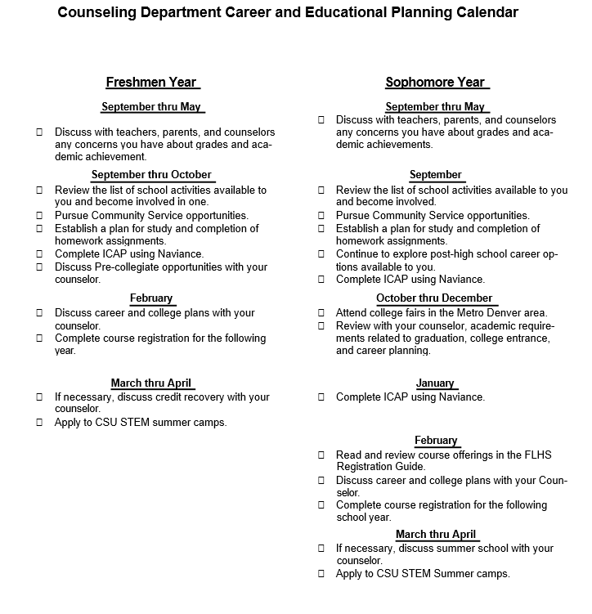

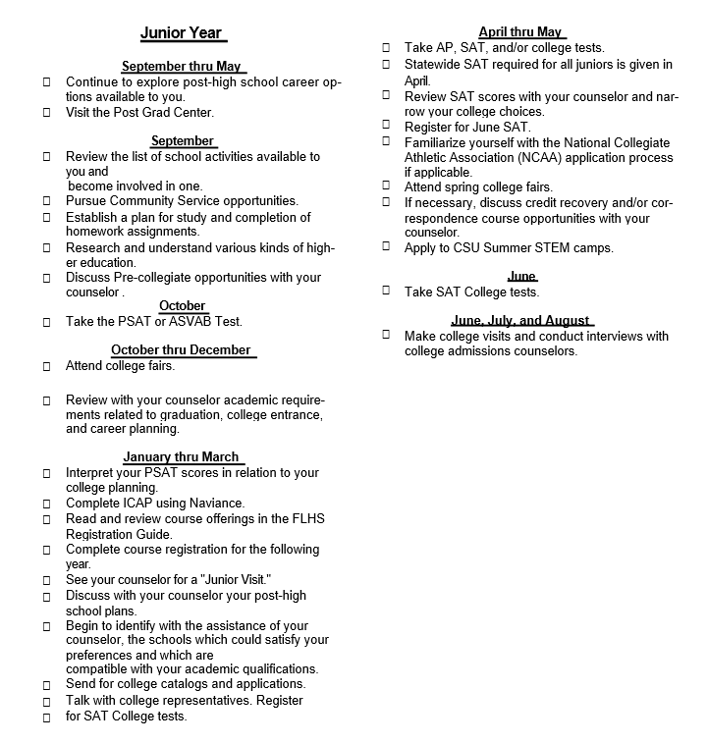
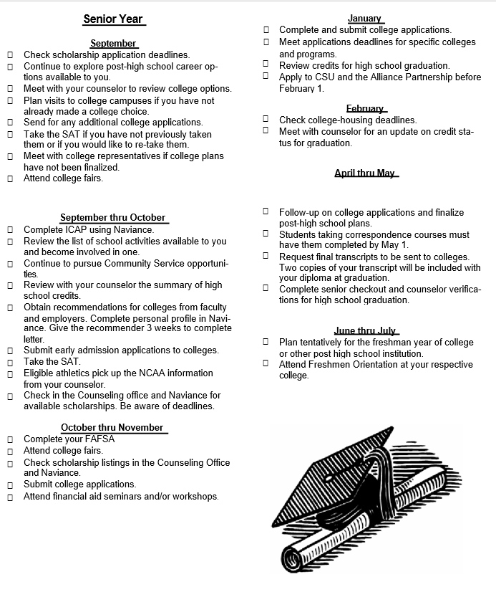

Notes
KYS

